IDM Configuration.

1. Login XI link. Click on square menu beside e-emphasys logo (left hand corner top)
2. Navigate to Infor ION API 🡺 Authorized Apps tab (Image 1)

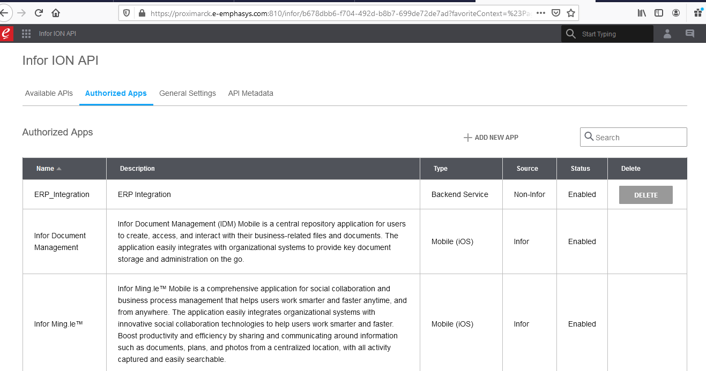

Image 1

1. Click on Add New App. You will get below screen (Image 2)

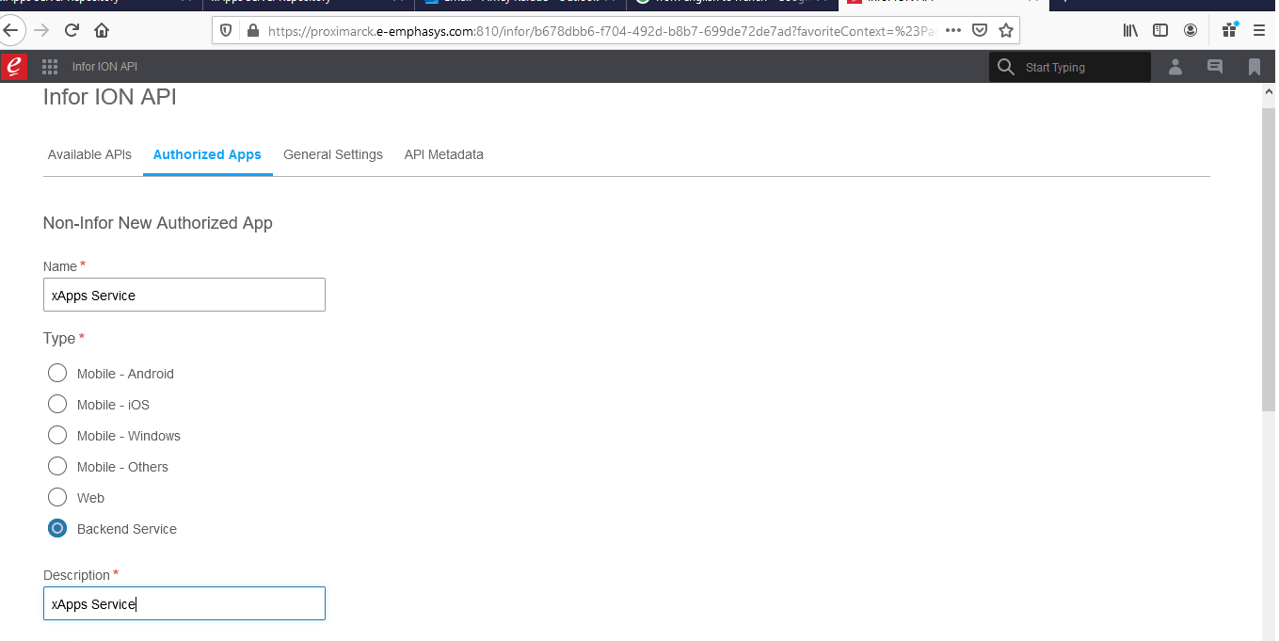

Image 2

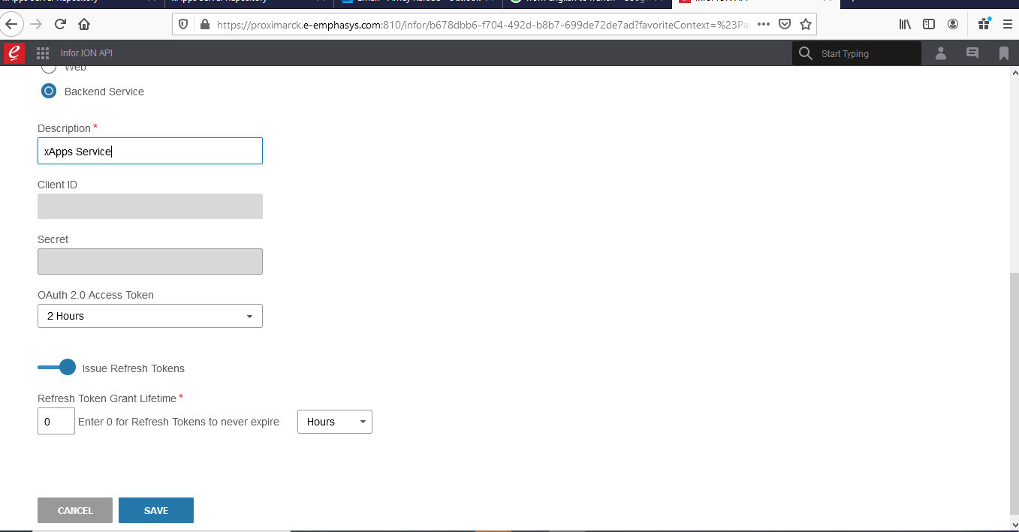

Image 3

1. Enter name as “xApps Service”. Select Backend service. Enter description “xApps Service”. Refer Image 2. Keep “OAuth 2.0 Access Token” as 2 hours refer image 3. Click save.
2. After Save you will get popup as Image 4. Click ok.:

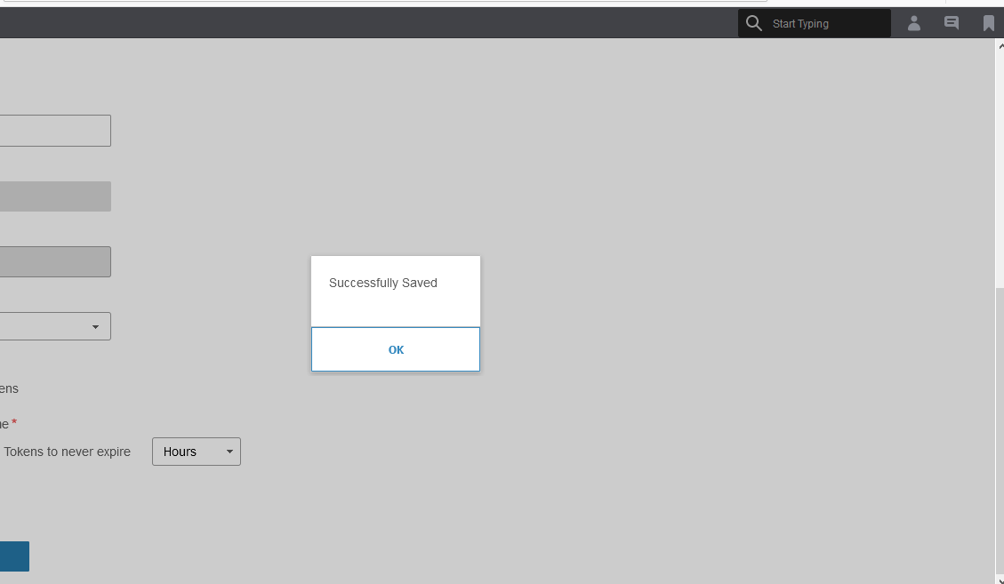

Image 4

1. After click ok you will get below screen Image 5:

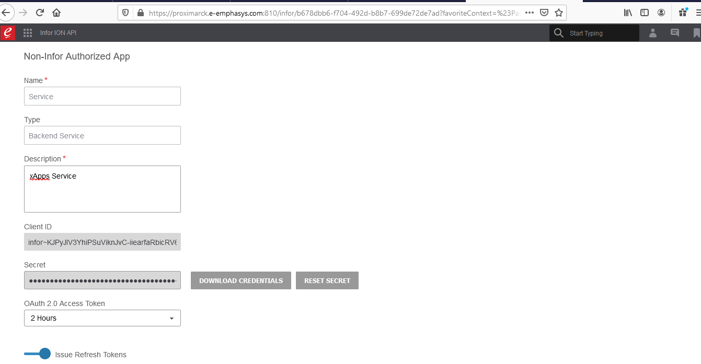

Image 5

1. Click on download credentials. After clicking download credentials you will get below screen Enter baan as username and select baan user .(Image 6)

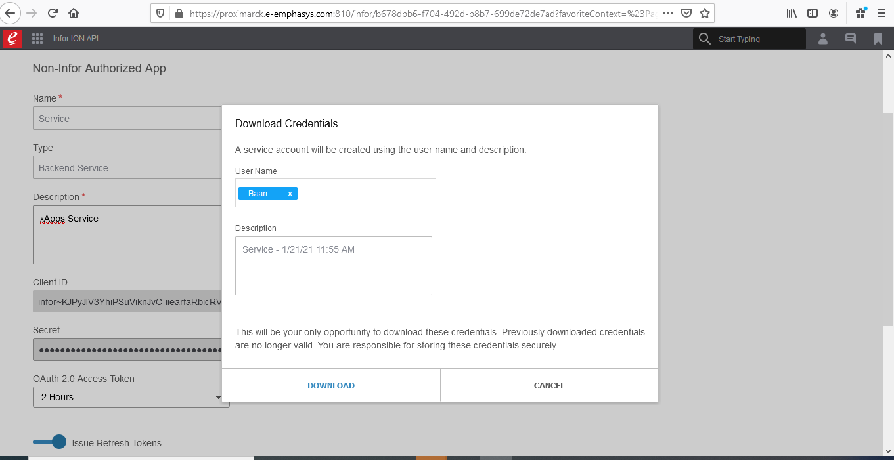

Image 6

8.Click on download and save the file on your machine (Image 7)

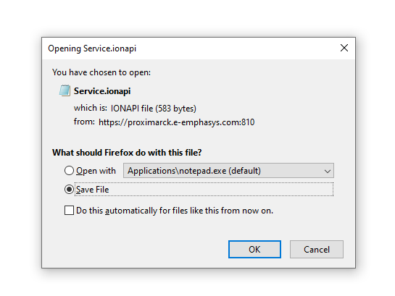

Image 7

9 . When you open the download file you will get below values. These are dummy values. Values change as per ERP environment:

{"ti":"infor","cn":"Service",

"ci":"infor~KJPyJIV3YhiPSuViknJvC-iiearfaRbicRV6IQjfLW8",

"cs":"Bwnon8ukk-_zqQ3iC-gNnHiUYw9WcsJBd2I2v3DpCHNDu5FdfixbE2SCGaWaeC1lpDCU0FvioPcTqa5yQ_YD_A",

"iu":"https://proximarck.e-emphasys.com:7443",

"pu":"https://proximarck.e-emphasys.com:810/InforIntSTS/",

"oa":"connect/authorize",

"ot":"connect/token",

"or":"connect/revocation",

"ev":"E1585858596","v":"1.0",

"saak":"infor#rQhMdyykcEKpXQ1LM2uatFz_jF_q2VGlqdzreNVZPF6XhIQ0V4TPSvyTc2ZsKS93IpXm7JzwwNFCQbqn1JkHQQ",

"sask":"16YxqicCbNQzNu3ppLkcB7xAyb8m04fe5PqoALlRJUUQIQZV6O_NeAzSV7u_fN1ubtD4tAgZXBGMMBavX5T0qg"

}

10. Now open IDM service web.config hosted on xApps environment. You will see below app keys:

<add key="aspnet:UseTaskFriendlySynchronizationContext" value="true" />

<add key="aspnet:UseTaskFriendlySynchronizationContext" value="true" />

<add key="DocumentUpload" value=" https://proximarck.e-emphasys.com:7443/infor/IDM/api/items" /> : Here copy value from “iu” from point 9 and paste here upto highlighted mark. We have highlighted with same color in point 9

<add key="DocumentSearch" value=" https://proximarck.e-emphasys.com:7443/infor/IDM/api/items/search" /> : Here copy value from “iu” from point 9 and paste her upto highlighted mark. We have highlighted with same color in point 9

<add key="DocumentCount" value=" https://proximarck.e-emphasys.com:7443/infor/IDM/api/items/count" /> : Here copy value from “iu” from point 9 and paste her upto highlighted mark. We have highlighted with same color in point 9

<add key="TokenUrl" value=" https://proximarck.e-emphasys.com:810/InforIntSTS /connect/token" /> : Here copy value from “pu” from point 9 and paste her upto highlighted mark. We have highlighted with same color in point 9

<add key="clientId" value="infor~4or2CVAhR8d3U5ExcDhF9747qJcQ80EaDKjg3VnPz_Y" /> :

Here copy value from “ci” from point 9 and paste her upto highlighted mark. We have highlighted with same color in point 9

<add key="clientSecret" value="Oxvec0LVqcOZhVElIahzZ_xWwTKjRMEBd4Rys1AU5UwqMH9GRime3c5Bgc2nw2KfCCHaLIiPngagV54m3II5iA" /> Here copy value from “cs” from point 9 and paste her upto highlighted mark. We have highlighted with same color in point 9

<add key="saak" value="infor#4q2pGkbgHrHb2iFi917Tqf9SvbAIZGO4Db3D66WG4rxPl6oNKqIHBwIDFC5ZLbt_J20LPIvbHN7iCjlfN_XPMg" /> Here copy value from “saak” from point 9 and paste her upto highlighted mark. We have highlighted with same color in point 9

<add key="sask" value="_XBf7uJHJXLSq1rapS1wqvgTUpMdP2eSuQQ0dkTQ_c5ObAQbDq7RAdQzQVZrGqOdGcszw0rCv853zkfpyrbRvg" /> Here copy value from “sask” from point 9 and paste her upto highlighted mark. We have highlighted with same color in point 9

Keep below keys as it is:

<add key="TwilioAccountSid" value="AC9eb68b6d8cffbfafa48edcf829672b4e" />

<add key="TwilioAuthToken" value="c98223d7fc899162fce943a070641636" />

<add key="TwilioFromnumber" value="+13236010369" />

<add key="GoogleApiKeyForShortKey" value="" />

<add key="TinyURLService" value="http://tinyurl.com/api-create.php?url= " />

11. Change local database connection string in IDM web config accordingly.

12. Download deployment package of IDM. Create folder in xAppsUAT/xAppsLive folder as IDM. Paste contents from Deployment package🡺 IDM🡺Application folder in IDM folder created.

Configure IDM in IIS. Create app pool for IDM in IIS as IDM_UAT/IDM_Live depending upon UAT or live environment.

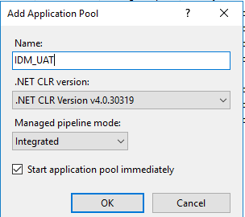

Image 8

13. After adding pool. Select the pool from list of pools and click advance settings and configure (Image 9). Enable 32 bit application to true. Identity set to local system. Idle time out 1440 . click ok

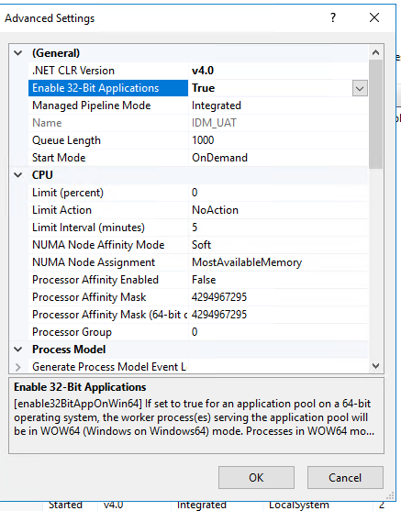

Image 9

14. Add VDE as IDMService in IIS with its pool configured. Give folder path where IDM application is stored in computer drive in IIS . Go to sites in IIS🡺xAppsUAT🡺Right click xAppsUAT🡺Add application🡺Alias name IDMService🡺App pool IDM_UAT🡺Physical path where application folder is kept🡺click ok . (Image 10). This is for UAT. Same will be for live

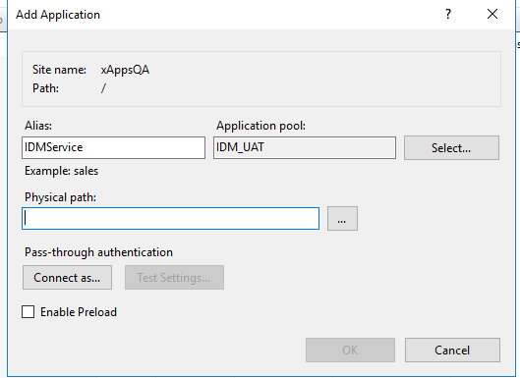

Image 10

15. Create database IDM_UAT in local database server and execute the scripts.

16. In deployment package for application 🡺 IDM🡺Application

17. In deployment package for scripts 🡺IDM🡺Scripts

18. Now in eScheduler and eServiceTech web config file add values in below keys:

In IdmDocumentManagemetService add value of “pu” in point 9 upto port number.

In IdmTokenAttributeService add value of DNS i.e DNS URL upto port number. For example : https://xxx.xxx.com:9004

<add key="IdmDocumentManagemetService" value="https://xidemo05.e-emphasys.com:7443/infor/IDM/api/" />

<add key="IdmTokenAttributeService" value="DNS/IDMService/IdmJsonService.svc" />

<add key="EnableIDM" value="false"/>

<add key="EnableIDM" value="true"/>