

e360 Deployment Guide

Release Date: July 2022

Document Version 1.0

© Copyright e-Emphasys ERP Development. All rights reserved by e-Emphasys Technologies Inc.

The information in this document is subject to change without prior notice. No part of this document may be reproduced, translated, stored, or transmitted in any form or by any means, electronic or mechanical, for any purpose, without the express written permission from e-Emphasys Technologies Inc.
The material contained in this document constitutes and contains confidential & proprietary information of
e-Emphasys. Access to this document does not pass on rights of any material, title or any other interest included in this document.
By accessing this document, the reader acknowledges that confidentiality will be maintained, and this document will be used only for the purpose for which it is intended. Despite due care taken by
e-Emphasys Development center, the document may contain some typographical mistakes or other errors. The information herein may not be complete or may not meet the readers’ specific requirements.
e-Emphasys Development center assumes no liability for any damages incurred, directly or indirectly, from any errors, omissions or discrepancies between the software and the information contained in this document.

e-Emphasys Technologies Inc.
2501 Weston Parkway, Suite 101, Cary, NC 27513, USA
Phone: + 1 919 657 6565
Fax: + 1 919 657 0773
e-mail: info@e-emphasys.com
Website: www.e-emphasys.com

Table of Contents
1. Introduction 6
1.1. About this document 6
1.2. Deployment Architecture 7
2. Prerequisites 8
2.1. Hardware Requirements for e360 Web 8
2.2 Software Requirements for e360 Web 8
2.3 Installation Prerequisites 8
3. Configuration of Database Components for e360 10
3.1 Configure C4WS Web Server 10
4. Downloading Deployment Package 12
5. Performing Backups (For Upgrade Only) 14
5.1 Backing Up the Database 14
5.2 Backing Up the Application 17
6. Deployment and Configuration of Components on the ERP Side 18
6.1 Deployment of e360 database scripts on ERP backend 18
7. Deployment and Configuration of Database Components on xApps Database Server 19
7.1 Deployment of e360 database 19
8. e360 Website Deployment 20
8.1 Installation: Web Site on xApps Server 20
8.2 Installation: e360 virtual directory on xApps server 23
8.3 Configuring MIME Types 25
8.4 Database Connections 26
9. Application configuration 28
9.1 Application configuration settings shown in the screenshot below must be configured for deployment. 28
9.2. User Column Customization table- Update the company column to customer company. 28
10. e360 Service configuration 29
10.1 Web.config 29
10.2 BDE configuration. 29
11. e360 Admin Configuration 30
11.1 Configure e360 Service URL and log file path. 30
12. e360 Apps 31
12.1 Configure links to download Android and iOS versions of the application. 31
12.2. Deployment of e360 mobile application 31
13. e360 Web application 35
14. Performing Smoke Testing for e360 Web 37
15. Maintaining QA Email Checklist 49
16. Update Link Repository 50

Table of Figures
Figure 1: This section explains components contributing to e360 8
Figure 2: Add an ERP Server Window 11
Figure 3: e360_Live / e360_UAT ERP Server Configuration 12
Figure 4: e360 Deployment Packages 13
Figure 5: Client Deployment Packages 14
Figure 6: Client Deployment Packages 14
Figure 7: Client Deployment Packages 14
Figure 8: SQL Server Details 15
Figure 9: Accessing the Back Up Option from the Context Menu 16
Figure 10: Adding Back Up 16
Figure 11: Back Up File Name 17
Figure 12: Click on OK button 17
Figure 13: Successful Backup Notification 18
Figure 14: e360 Folder 18
Figure 15: e360 Application Pool 21
Figure 16: xApps UAT Application Pool 21
Figure 17: xApps UAT New Application Pool 22
Figure 18: New Application Pool Settings 23
Figure 19: Add new website 23
Figure 20: New website advance settings 24
Figure 21: Add new virtual directory 25
Figure 22: Mapping the physical path 25
Figure 23: Mapping the physical path 26
Figure 24: Internet Information Services (IIS) Manager 26
Figure 25: Add MIME Types Dialog Box 27
Figure 26: Web.config location 28
Figure 27: Update customer specific connection strings 28
Figure 28: Update database application configurations 29
Figure 29: Update the SSL settings, admin links, suffix, IDM path and Service path 30
Figure 30: Update the BDE URLs in web.config 30
Figure 31: Update admin site web.config 31
Figure 32: Copying folders 32
Figure 33: Index.html File 33
Figure 34: Setting the Version, Environment and Customer URL 33
Figure 35: Update user guide link 34
Figure 36: Folder view of plist file folder 34
Figure 37: Update plist file with latest link and version 34
Figure 38: Update android and iOS build files 35
Figure 39: Update QR code image 35
Figure 40: Update the version number and build number in index.html 36
Figure 41: Update the version number and build number in e360QR.html 36
Figure 42: Update references path on Index.html 37
Figure 43: Update references path on main.js 37
Figure 44: Update google map API on CommonFunctionService.js 38
Figure 45: Update service path on ConfigurationService.js 38
Figure 46: Check service URL 39
Figure 47: Click on any service and check the service endpoint 39
Figure 48: Check e360 admin URL 40
Figure 49: Login using admin / admin1234 credentials 40
Figure 50: Add new users 41
Figure 51: Save user success message 41
Figure 52: New user email 42
Figure 53: Role management list view 42
Figure 54: Application Configuration page 43
Figure 55: Upload image new look 43
Figure 56: Check e360 web 44
Figure 57: Login using admin credentials 44
Figure 58: e360 Web home screen 45
Figure 59: Click on equipment’s to view product categories 45
Figure 60: Sub product category view 46
Figure 61: Check an equipment details page 46
Figure 62: Click on text button to view texts 47
Figure 63: Check rental availability 47
Figure 64: View parts 48
Figure 65: Parts advance search 48
Figure 66: Parts list view 49
Figure 67: Customer search view 49
Figure 68: Customer list view 50
Figure 69: Customer details page 50
Figure 70: Link repository 52
Figure 71: Go to xApps link repository 52
Figure 72: Search for required customer 53
Figure 73: Add or update new customer specific data 53
Figure 74: Fill up the required data 54
Figure 75: Edit the existing entry 54
Figure 76: Update the details and save it 55

Introduction
E360 is a read only application used by sales representatives.
E360 shows data from below 4 ERP modules, and it is available as Native (IOS/Android) application as well as Web based application.
  - Equipment
  - Rental
  - Parts
  - Customer

1.1. About this document
The purpose of this document is to provide guidance in deployment & configuration of e360.
The deployment involves the following steps
- Deployment of database stored procedures on eXtend database
- Deployment and Configuration of SQL Server database on xApps Server
- Deployment of e360 Web Application
- Managing IIS application settings
- Verification of Deployment

1.2. Deployment Architecture
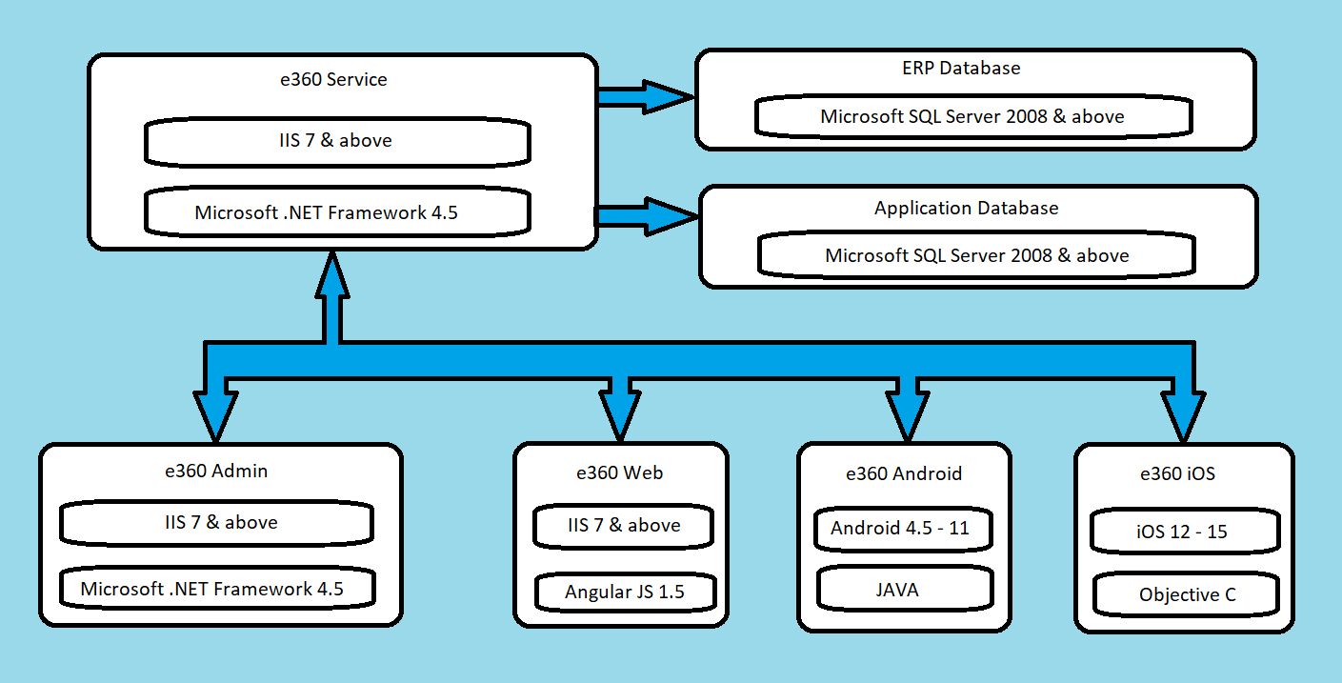
Figure 1: This section explains components contributing to e360

e360 Service Application: Contains Business Logic Components.
  - e360 Service: Contains Business Logic Components
  - e360 Admin: This is web-based application to manages different settings for the application as well as user management.
  - e360 Web: This is web-based application developed as single page application using Angular JS 1.5.
  - e360 Android and iOS: This is Native platform apps which can be installed on respective platform devices.
  - Application Database: e360 database maintains information about all users and different configuration settings.
  - e-Emphasys ERP DB: ERP database from where e360 fetch information required from ERP.

Prerequisites
The following software(s) or component(s) must be preinstalled on the e360 Server.

2.1. Hardware Requirements for e360 Web
Component | Minimum Requirement
Processor | Intel Xeon class CPU processor, 2 vCPUs, 2 GHz per core
Memory | 6 GB RAM
HDD | 50 GB. Additional space may be needed depending on how many images are uploaded by users from the app.

2.2 Software Requirements for e360 Web
Component | Minimum Requirement
Operating System | Windows Server 2016
IIS | 10.0
.NET Framework | 4.5
SQL Server | Microsoft SQL Server 2016
C4WS | Web UI 10.15 & above

2.3 Installation Prerequisites
Please install ERP solutions that are required by the application.
Please install either the original solution listed below or the BASE solution depending on whether ERP solution level is at F8 or FP12, respectively.
Sr. No. | Product Version | Original Solution # | BASE Solution for E50C
1 | 1.4.0.2 | 59129_INT, 59129_INT_1, 66265_INT, 66730_INT, 67224_INT, 68588_INT, 70867_INT, BASE_INT_ESA,  74521_INT, 76583_INT, 105785_INT, | BASE_E40CE401,  BASE_E40E401_2,  BASE_E40E401_7,
2 | 1.5.0.0 | No new solutions | No new solutions
3 | 1.5.1.0 | 116396_INT | 116396_INT
4 | 1.5.2.0 | - 122973  To install this solution Run  correction program  erecp122973 in update  mode.  - BASE_IDM_1  Additional attributes id21 to id26 added to the Generic document type. This solution is applicable for e-Emphasys ERP 5.0 only.  Post-Installation:  Upload additional file IDM_Generic_DocType.xml after installation of the solution. Please refer below steps to upload file.  - Go to Configuration Exporter and Importer  - (Navigation Path - Document Management > Menu > Configuration Exporter and Importer)  - Go to the Import tab and select XML which is available on the path below  - $BSE\application\tcE50U_1_ex01\btcext\  bextIDM_Generic_DocType.xml  - To load imported XML file, click on Import XML File. | 122973, BASE_IDM_1
5 | 1.5.5.0 | - 199441_INT  This solution needs to be added for MLE support | 199441_INT

Configuration of Database Components for e360
This chapter explains the configuration of the database components such as the C4WS Web Server and ERP Integrator Service for e360.

3.1 Configure C4WS Web Server
The steps for configuring the C4WS Web Server are explained below.
- Go to the C4WS URL and click the ERP Servers page link.
- On the screen which appears, click the Add ERP Server button.
- Select the Create ERP Server without using any of the available LN UI Environments options and click Continue.
- The Add an ERP Server window opens as illustrated below.
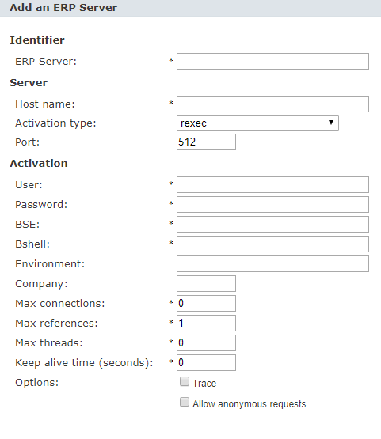
Figure 2: Add an ERP Server Window
- Maintain the ERP Server Name as e360_Live_{Company} / e360_UAT_{Company}, the Host Name as the ERP Application IP and the Password as Password.
- The BSE and Bshell will be provided by the IS team.
- To configure the e360_Live_{Company} / e360_UAT_{Company} ERP Server, specify the following:
Field | Value
Max connections | 1
Max references | 0
Max threads | 2500
Time Out (Keep alive time in seconds) | 600
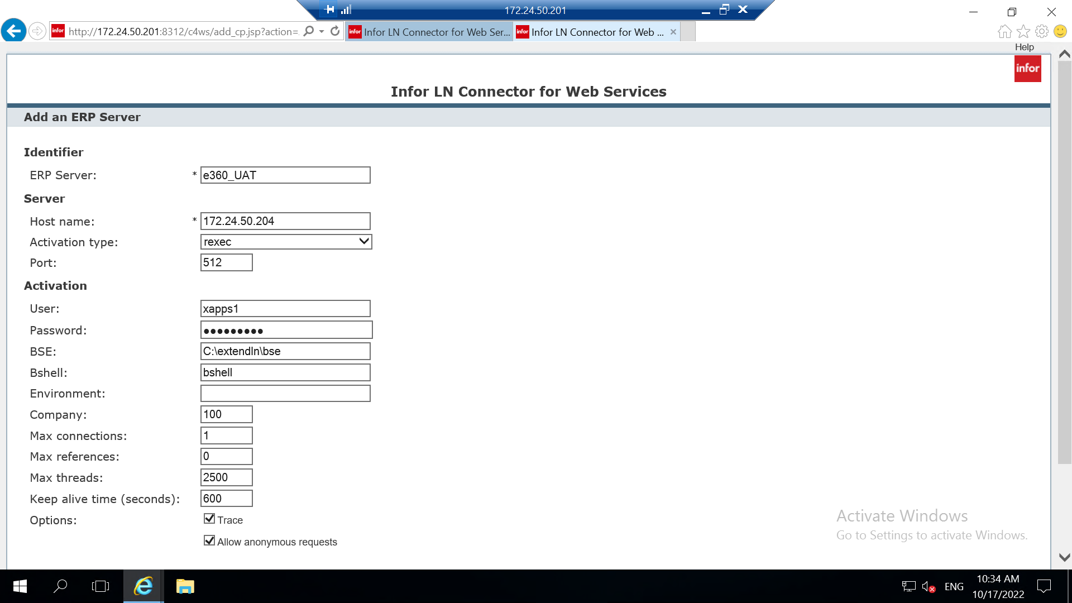
Figure 3: e360_Live / e360_UAT ERP Server Configuration
- Select the Trace and Allow anonymous requests options in the Add an ERP Server window.
- The list of BDEs to configure under this setting are as follows:
- ESAEquipConfigDetails
- ESAEquipmentRentalPricing
- ESAInvoiceHeaders
- ESAInvoiceLines
- ESAOpenQuotesHeader
- ESAOpenServiceOrders
- ESAOrderHistory
- ESAOrderLines
- ESAPartsPricing
- ESAQuoteLines
- ESASalesReceivables
- TextDetails

Downloading Deployment Package

This chapter explains the steps to download the deployment package.
We need to download two deployment packages for e360.
1.Common
2.Client Specific (Client Web.config, Database Script)
Always download the new deployment package using the link provided. You must never use the existing package as the deployment package is constantly updated.
- Open the available browser on the server and go to the link below for common package:
https://xapps1.e-emphasys.com:10000/Deployment/New/e360

The Deployment page is displayed with the deployment packages for eService Tech as illustrated below.

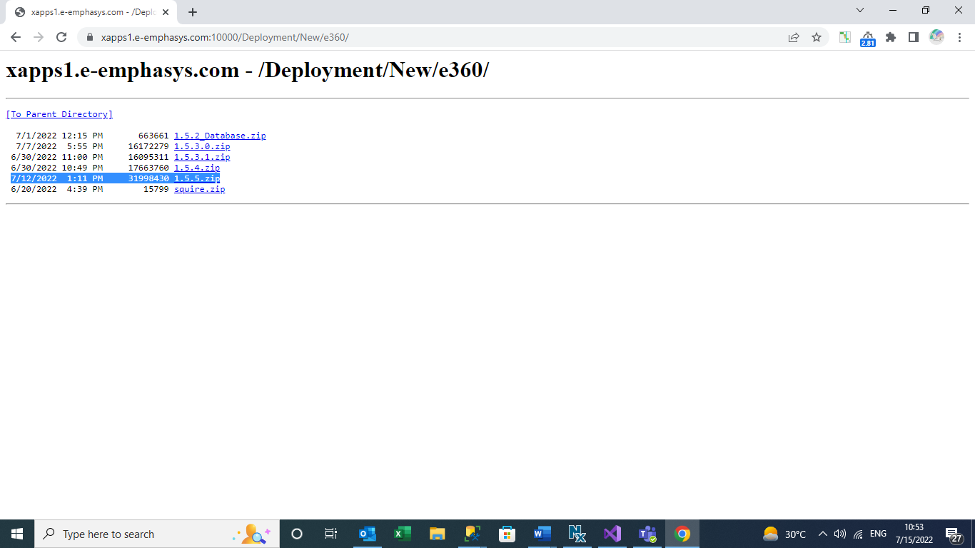
Figure 4: e360 Deployment Packages
- Click the required package to download it. For example, if version 1.5.5 is required, then click the 1.5.5.zip in the list.
- The zip file will be downloaded in the Downloads folder in C drive.
- Copy the zip file from this folder and paste it in the scrap folder in the respective drive on the server. Click here for the client wise path details to paste the deployment package.
- Extract the zip file to get the common deployment package files.
- Open the available browser on the server and go to the link below for client specific package:
https://xapps1.e-emphasys.com:10000/Deployment/New/Client/
Click on required client name for example as shown below- Arnold click on required product
Here we will click on client as shown in below image.
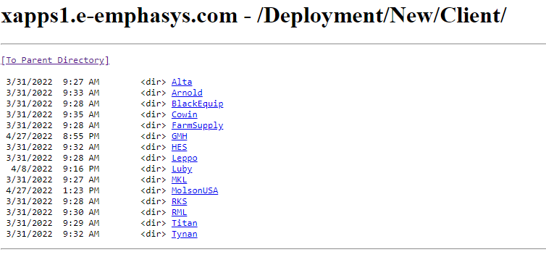
Figure 5: Client Deployment Packages
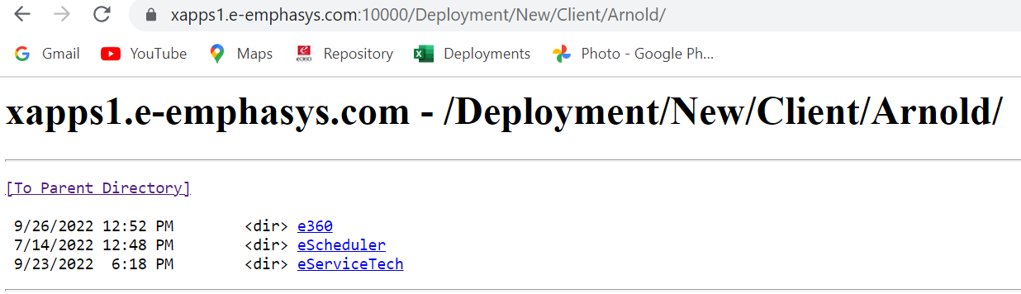
Figure 6: Client Deployment Packages
Download Live or UAT as per requirement package by clicking respective .zip file as shown below-
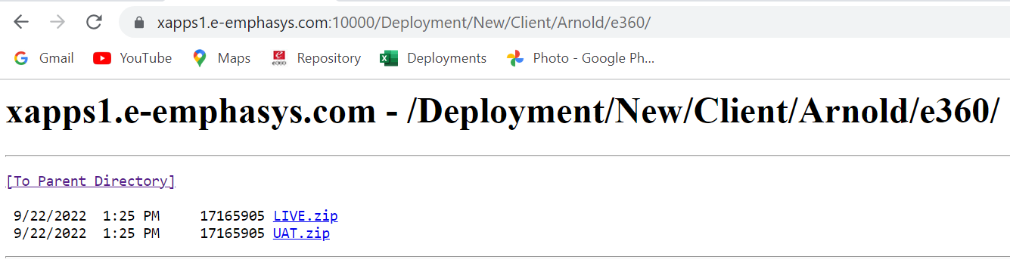
Figure 7: Client Deployment Packages
- The zip files will be downloaded in the Downloads folder in C drive.
- Copy the zip file from this folder and paste it in the scrap folder in the respective drive on the server. Click here for the client wise path details to paste the deployment package.
- Extract the zip file to get the deployment package files.

Performing Backups (For Upgrade Only)
There are two types of deployments, viz., Upgrade and Fresh. Backup is not required for Fresh deployments. Backup must be taken for Upgrade. This chapter explains the process of performing the backup for the database as well as e360 application.

5.1 Backing Up the Database
This section explains the steps to back up the database.
- Open SQL Server Management Studio and connect with the server details below.
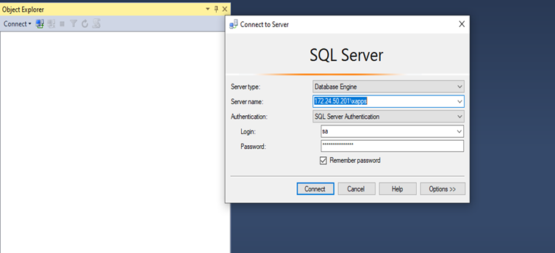
Figure 8: SQL Server Details
- Select the database as e360_Live or e360_UAT based on the environment (Live / UAT).
- Select the database and right click the database name to access the context menu. Select the Back Up sub option from the Tasks option in the context menu as illustrated below.
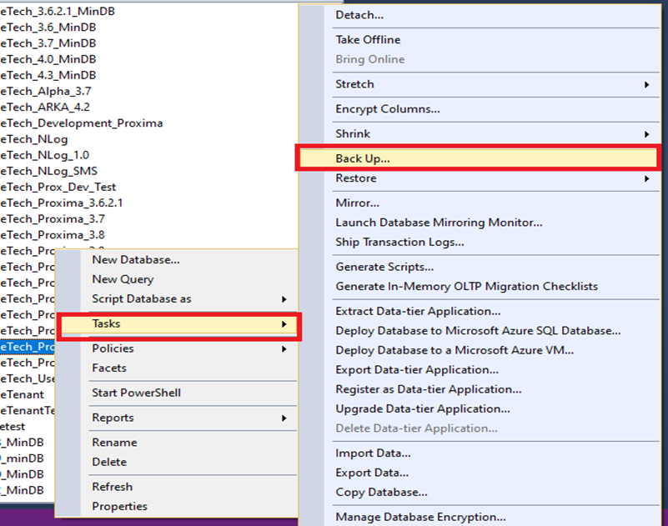
Figure 9: Accessing the Back Up Option from the Context Menu
- Click the Add button as illustrated below.
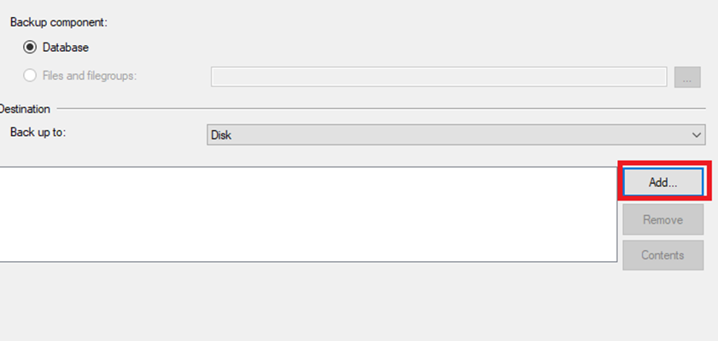
Figure 10: Adding Back Up
- Specify the file name path. The naming convention for the Back Up file is as follows:
Database name_ Date_bak
For example, the backup file name for the e360_UAT database on 26th September 2022 is e360_UAT_26Sep2022.bak.
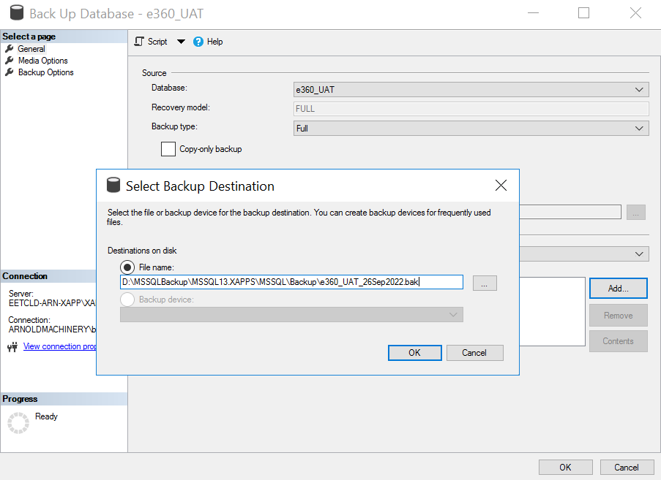
Figure 11: Back Up File Name
- Click the OK button in the Select Backup Destination popup.
- Click the OK button on the main screen.
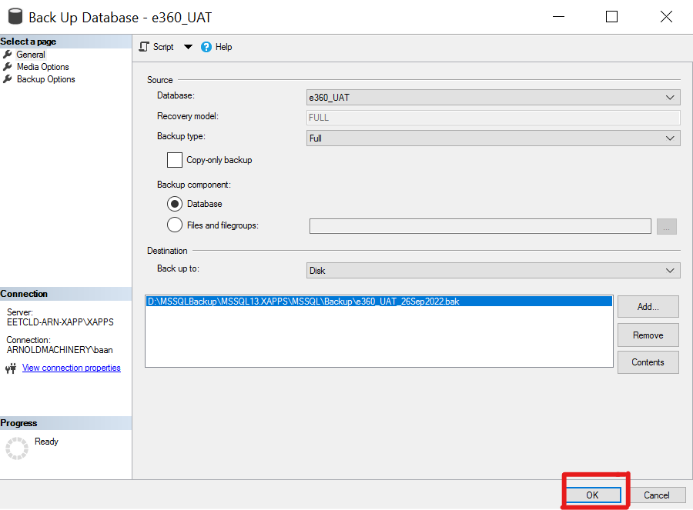
Figure 12: Click on OK button
- If the backup is completed successfully, a message for the same is displayed as illustrated below.
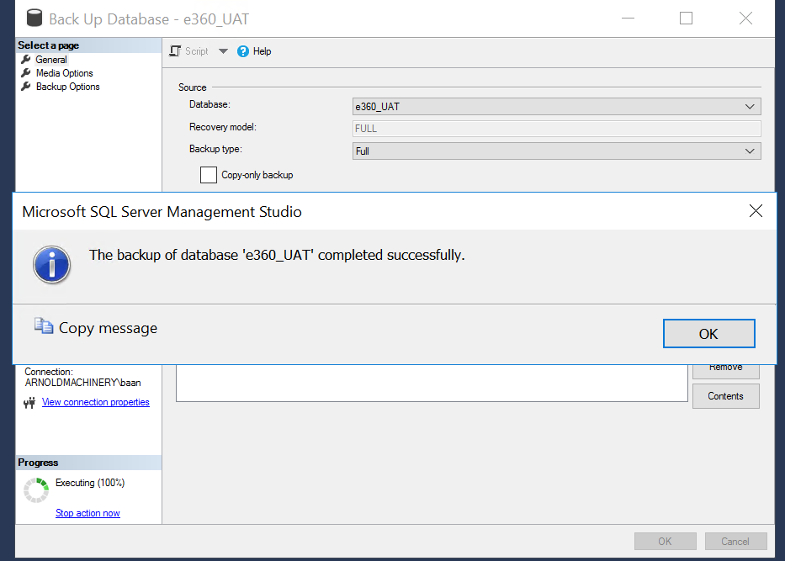
Figure 13: Successful Backup Notification

5.2 Backing Up the Application
This section explains the steps to back up the application.
- Copy the folders highlighted in the below screen from e360 folder.
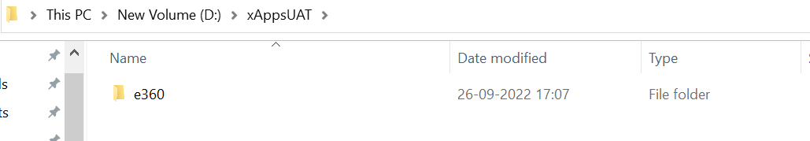
Figure 14: e360 Folder
- Create a new folder inside the Backup folder on the server with name as e360 followed by the date. For example, e360_26Sep2022.
- Paste the copied folders in the newly created folder.

6. Deployment and Configuration of Components on the ERP Side

6.1 Deployment of e360 database scripts on ERP backend
6.1.1 SQL Server Installation Script Names
6.1.1.1 ERP SP for version 1.5.2.0 - 1.5.9.0
  - Database/eXtend/ERP_eSales_{version}.sql

7. Deployment and Configuration of Database Components on xApps Database Server

7.1 Deployment of e360 database
The e360 database package needs to be deployed on the xApps Server’s Database. The package consists of –
7.1.1 If upgrade for version 1.5.2.0 to 1.5.9.0
a. Database/Local/004_upgradescript.sql
b. Database/Local/003_sp.sql

7.1.2 If new deployment of local database for version 1.5.2.0 – 1.5.9.0
a. Database/Local/001_tables.sql
b. Database/Local/003_sp.sql
c. Database/Local/002_masterdata.sql (if present in deployment package)

7.1.3 IDM attributes
a. 001_IntegrationDocumentManagment tables.sql
Make sure we check IDM attribute and mapping table before executing this script. If tables are not present, then execute the above script.

b. 002_IntegrationDocumentManagment.sql
Make sure we check IDM attribute and mapping table before executing this script. If product e360 entries are not present, then execute the above script.

The above are the lists of scripts for Local SQL backend. Install the necessary scripts accordingly with exact sequence.

8. e360 Website Deployment

8.1 Installation: Web Site on xApps Server
- Copy folder to appropriate location on xApps Server.
- Open Internet Information Services (IIS) Manager.
- Create N8.ew Application Pool,
    - Select <<Server Name>> -> Application Pools
    - Right click on Application Pools
    - Select Add Application Pool.
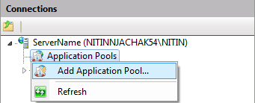
a
c
Figure 15: e360 Application Pool
    - Name the Application Pool (e.g., xApps_<<Environment>>)

    - Select .NET Framework v4.0.30319 from dropdown list
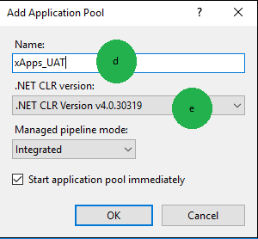
Figure 16: xApps UAT Application Pool
    - Click on OK.
    - Application Pool created successfully.
    - Verify same by selecting Application Pools node in connections.
    - Select newly created application pool.
    - Select Advanced settings as shown in below screen shot.
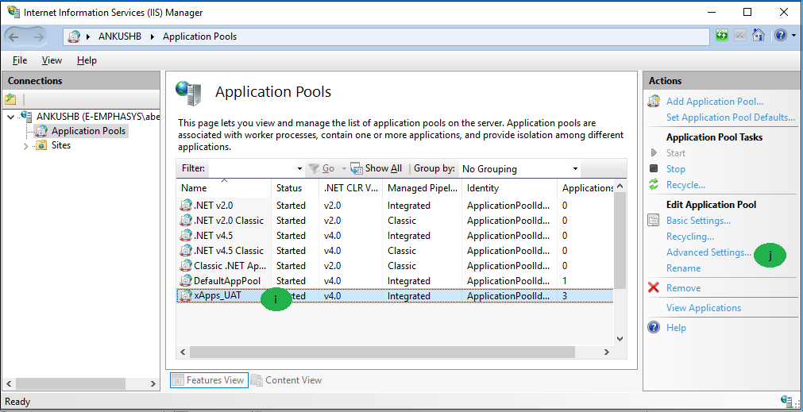
Figure 17: xApps UAT New Application Pool
    - Keep Identity as localService
    - Keep Enable 32-bit Applications to True
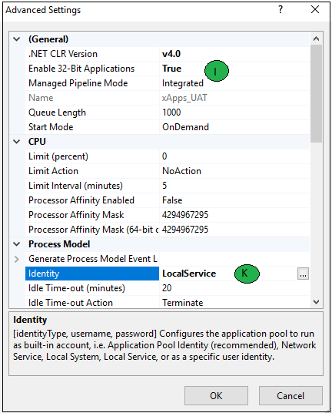
Figure 18: New Application Pool Settings

- Create new application pool for e360 (e.g., e360_<<Environment>>) and follow the same steps above.
- Create xApps_<<Environment>>Website
    - Add New Website
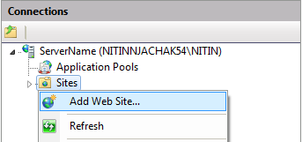
a
Figure 19: Add new website
    - Enter site name (e.g., xApps_<<Environment>>)
    - Select application pool.
    - Select Physical path
    - xApps_UAT Website Created.
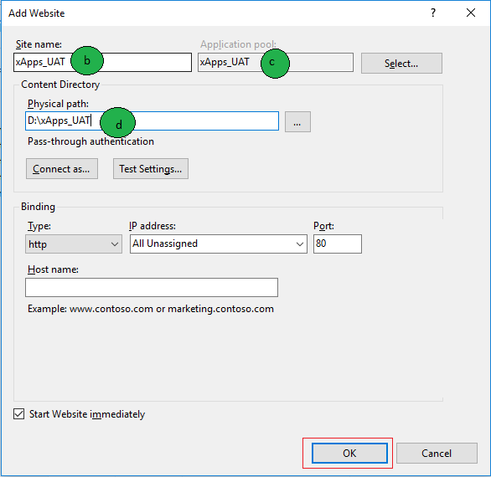
Figure 20: New website advance settings

8.2 Installation: e360 virtual directory on xApps server
    - Create new virtual directory for e360
- Right click on xApps_<<Environment>> Website
- Click Add Application
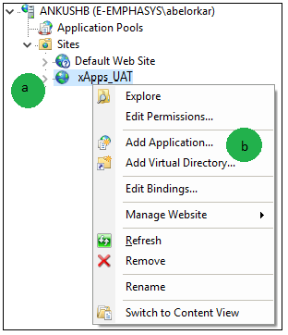
Figure 21: Add new virtual directory
- Provide Alias name as e360
- Select application pool e360 which we have created in step 5.1 above
- Select physical path for e360 folder.
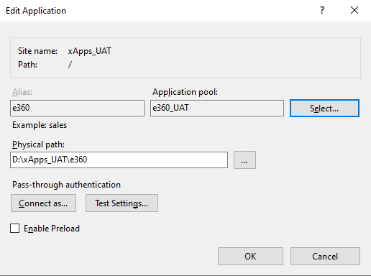
Figure 22: Mapping the physical path

- Create a new virtual directory for App, Service, Admin under e360 with respective physical path.
- Create a new virtual directory for e360Web under xApps_UAT with respective physical path.

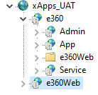
Figure 23: Mapping the physical path
After configuring all applications IIS should look like this

8.3 Configuring MIME Types
The steps to configure MIME Types are explained below.
- Open the Internet Information Services (IIS) Manager and navigate to the Sites node as illustrated below.
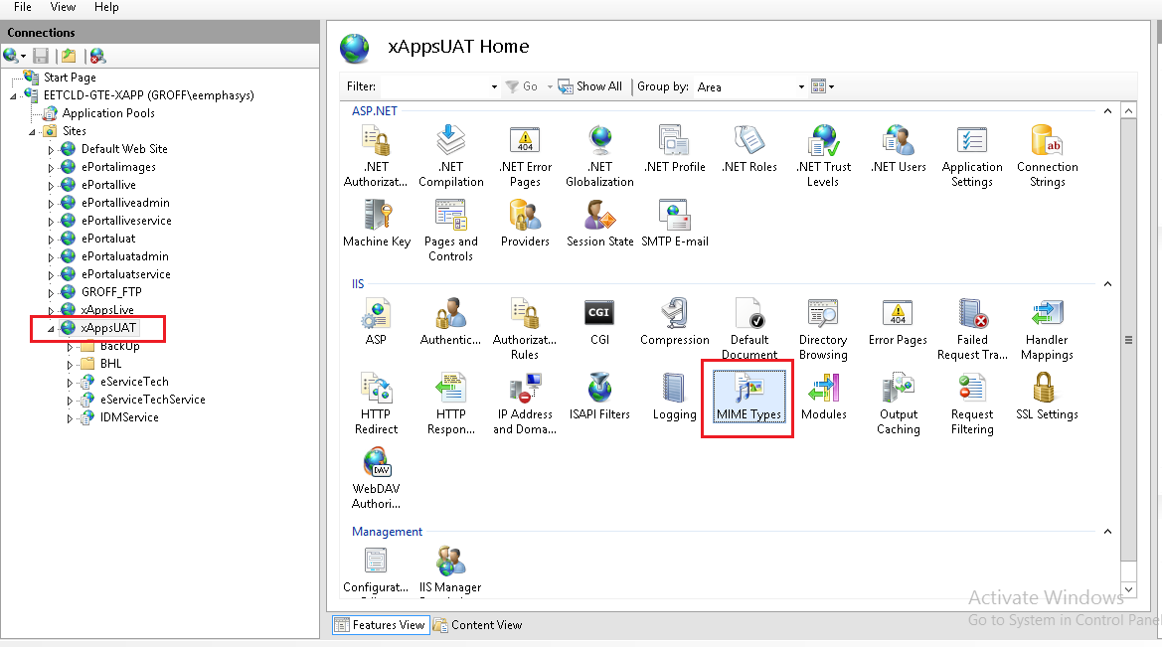
Figure 24: Internet Information Services (IIS) Manager
- Select the MIME Types icon from the Home page and double-click it.
- In the Action pane on the right-hand side, click the Add option. The Add MIME Types dialog box appears as illustrated below.
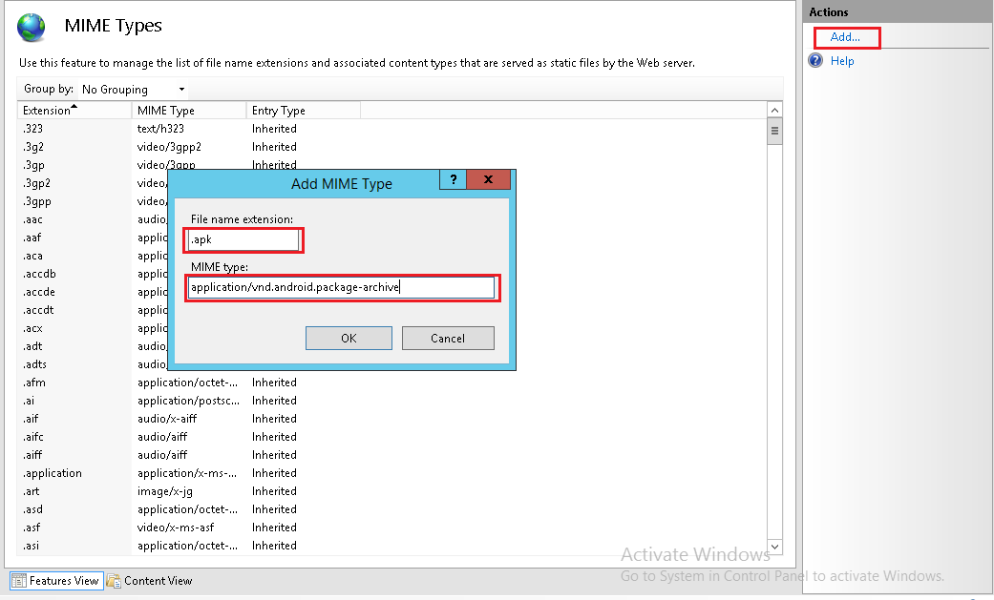
Figure 25: Add MIME Types Dialog Box

- In the Add MIME Types dialog box, specify the File name extension and the MIME type.
File Name Extension | MIME Type
.ipa | application/octet-stream
.apk | application/vnd.android.package-archive
.plist | text/plain

8.4 Database Connections
A connection string provides the information that an application must have to communicate with a particular database. A connection string usually supplies the server or location of the database server, the database to use, and the authentication information to access the database. To update the Connection Strings for database connectivity
8.4.1 Description of Connection String
Name | Description
- ConnectionString | Connection string used to connect e360 SQL Server backend database. You need to keep this connection string into service web.config.
- BaanDBConnectionString | Connection string used to connect ERP backend database. You need to keep this connection string into service web.config.

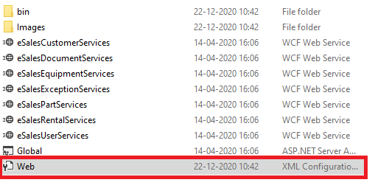
1

Figure 26: Web.config location
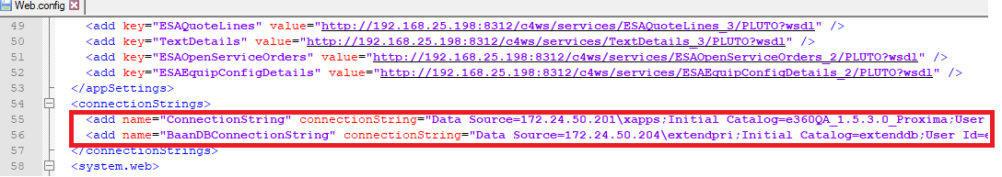
1
Figure 27: Update customer specific connection strings

9. Application configuration

9.1 Application configuration settings shown in the screenshot below must be configured for deployment.
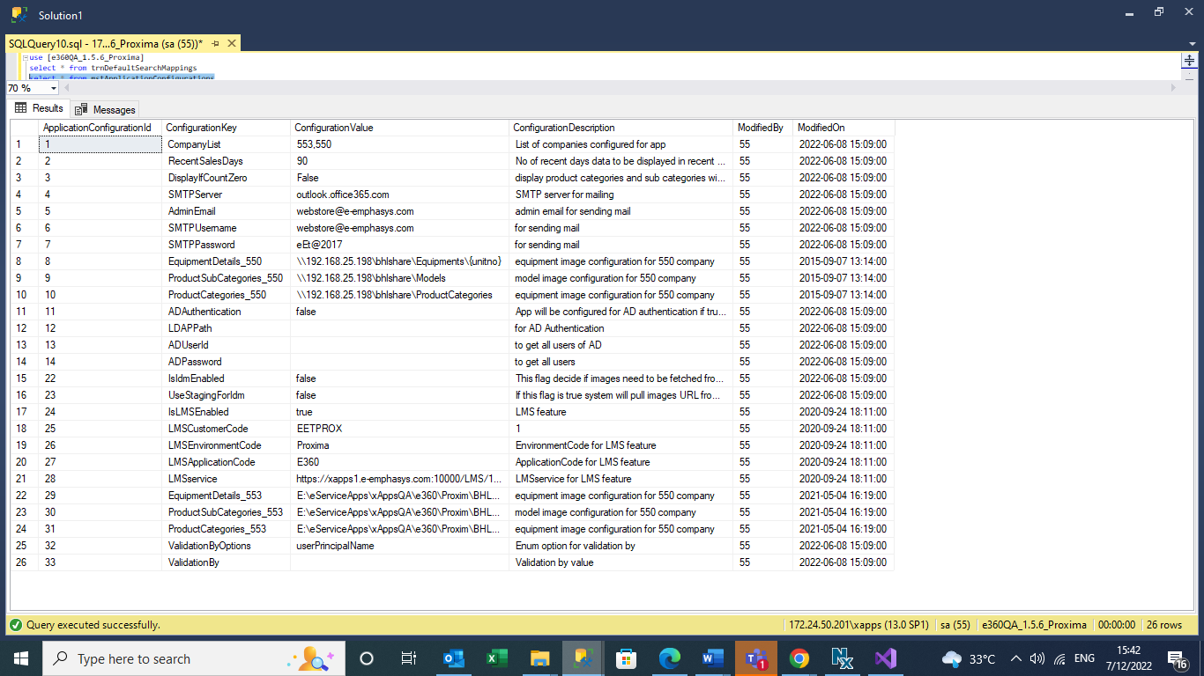
Figure 28: Update database application configurations

9.2. User Column Customization table- Update the company column to customer company.
Table mstUnitGridColumnCustomize of local xapps database should hold 12 entries for each company number. Make sure you update entries for current company.

10. e360 Service configuration

10.1 Web.config
We need to configure the e360 service based on the application environment and version.
The settings shown in the screenshots below need to be modified accordingly.
Note: IsSSL and SMTPPort setting is used for SMTP configuration.

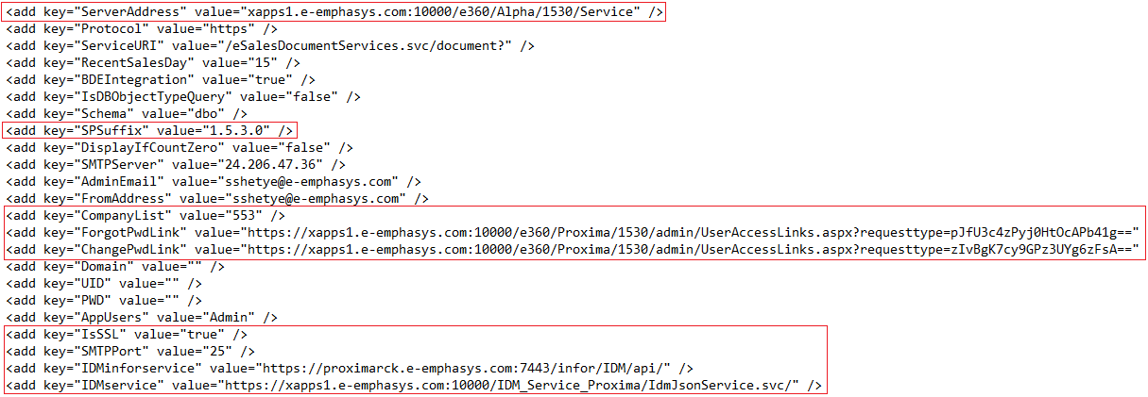
Figure 29: Update the SSL settings, admin links, suffix, IDM path and Service path

10.2 BDE configuration.
Each BDE needs to configure based on the URL from IS team.
Application will find specific URL for company and if it is not found it will check for generic URL without company number in KEY.

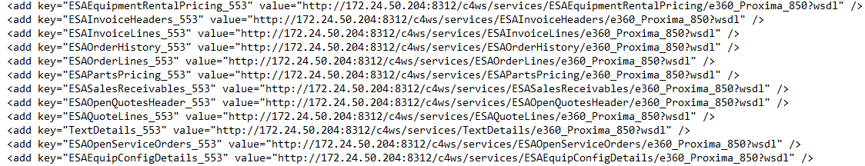
Figure 30: Update the BDE URLs in web.config

11. e360 Admin Configuration

11.1 Configure e360 Service URL and log file path.
      - RootService: This is e360 service URL.
      - LogFilePath: This is used to configure log file path.
      - EnableLogging: if set True, it will enable logging in Admin website.

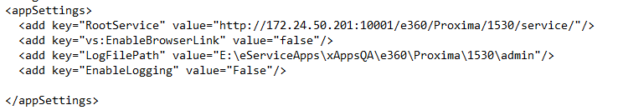
Figure 31: Update admin site web.config

12. e360 Apps

12.1 Configure links to download Android and iOS versions of the application.
- In Index.htm page
  - Plist file path
  - APK file path
  - Environment name (Live/UAT/QA)
  - Application version
  - iOS build implementation user guide URL (bottom side of page)
- e360QR.htm Page
  - Environment name (Live/UAT/QA)
  - Application version
- Inside image folder
  - Create a new QA code image from the app download link and place it inside this folder
- Inside installables folder.
  - Edit plist file and update the domain URL for ipa file.

12.2. Deployment of e360 mobile application
- Only for Fresh Deployment-
This chapter explains the deployment of the e360 Mobile Application.
- Copy files from the apps folder in the deployment package and paste it in the App folder.
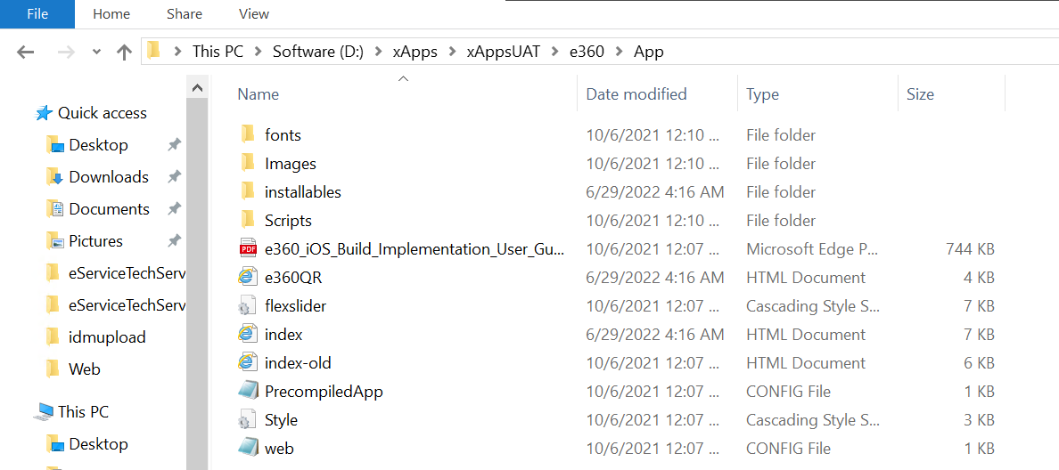
Figure 32: Copying folders
- Open the index.html file present in App folder in notepad.
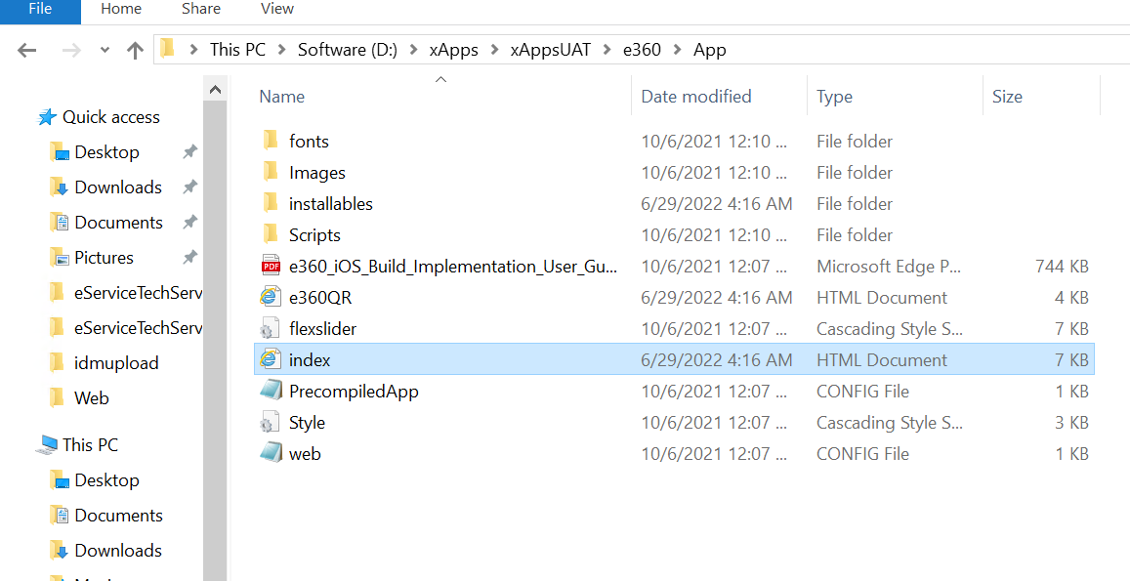
Figure 33: Index.html File
- Search the header title in the file and set the required version and environment (Live or UAT) as per requirement.
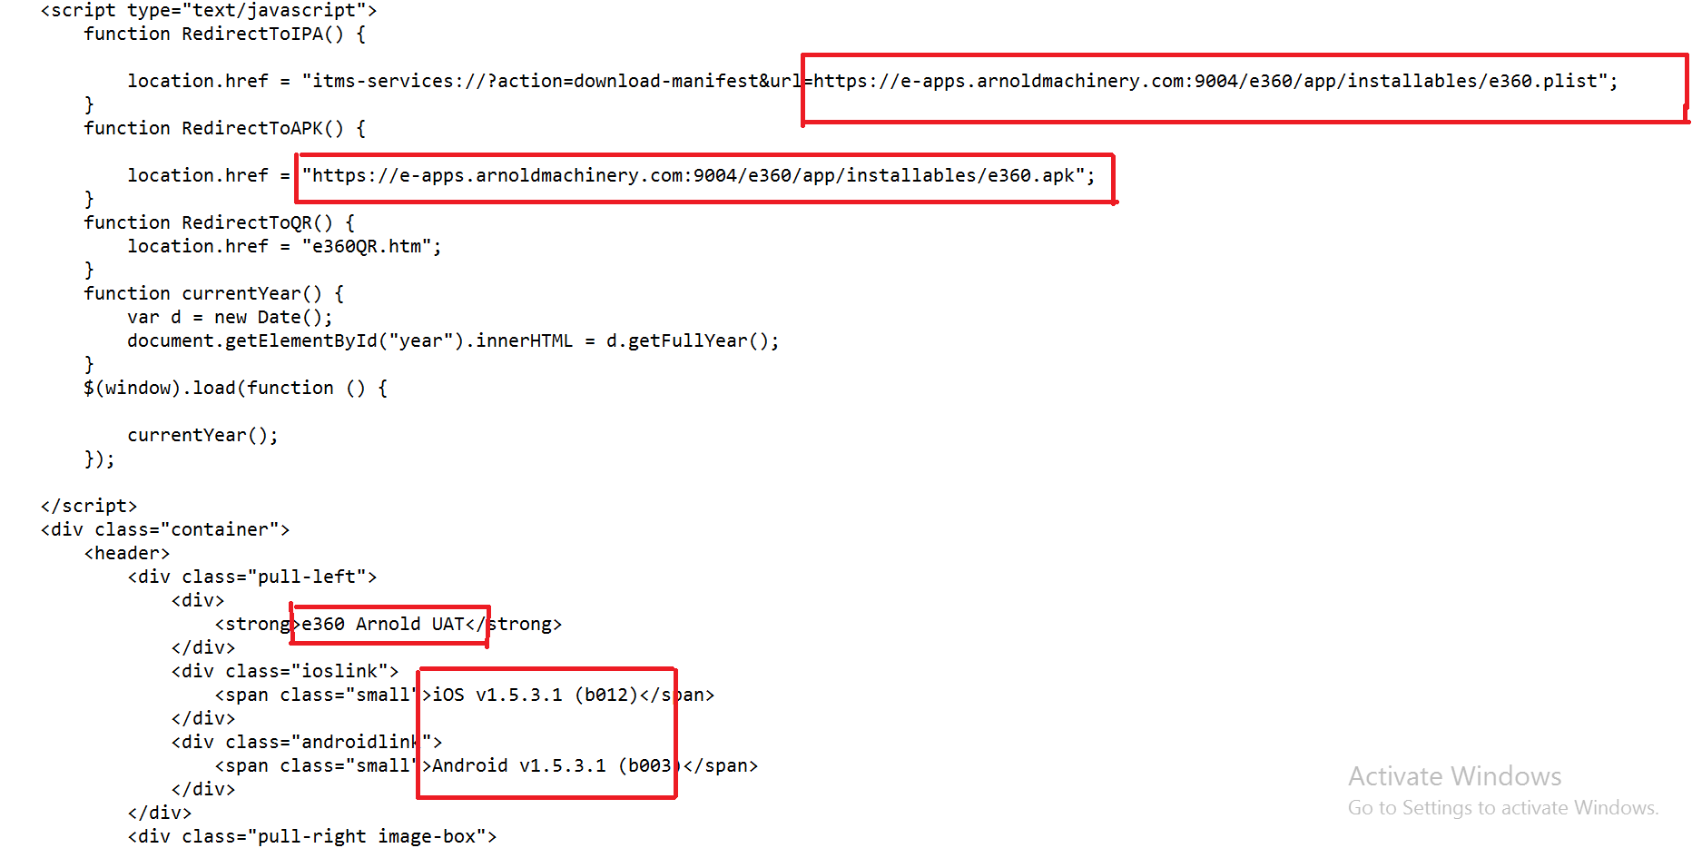
Figure 34: Setting the Version, Environment and Customer URL
- Search RedirectToIPA and RedirectToAPK in index.html file and replace the respective customer URL in location.href as highlighted in below screen.
- Search Implementation_User_Guide.pdf in index.html file and replace the respective customer URL in its href tag.
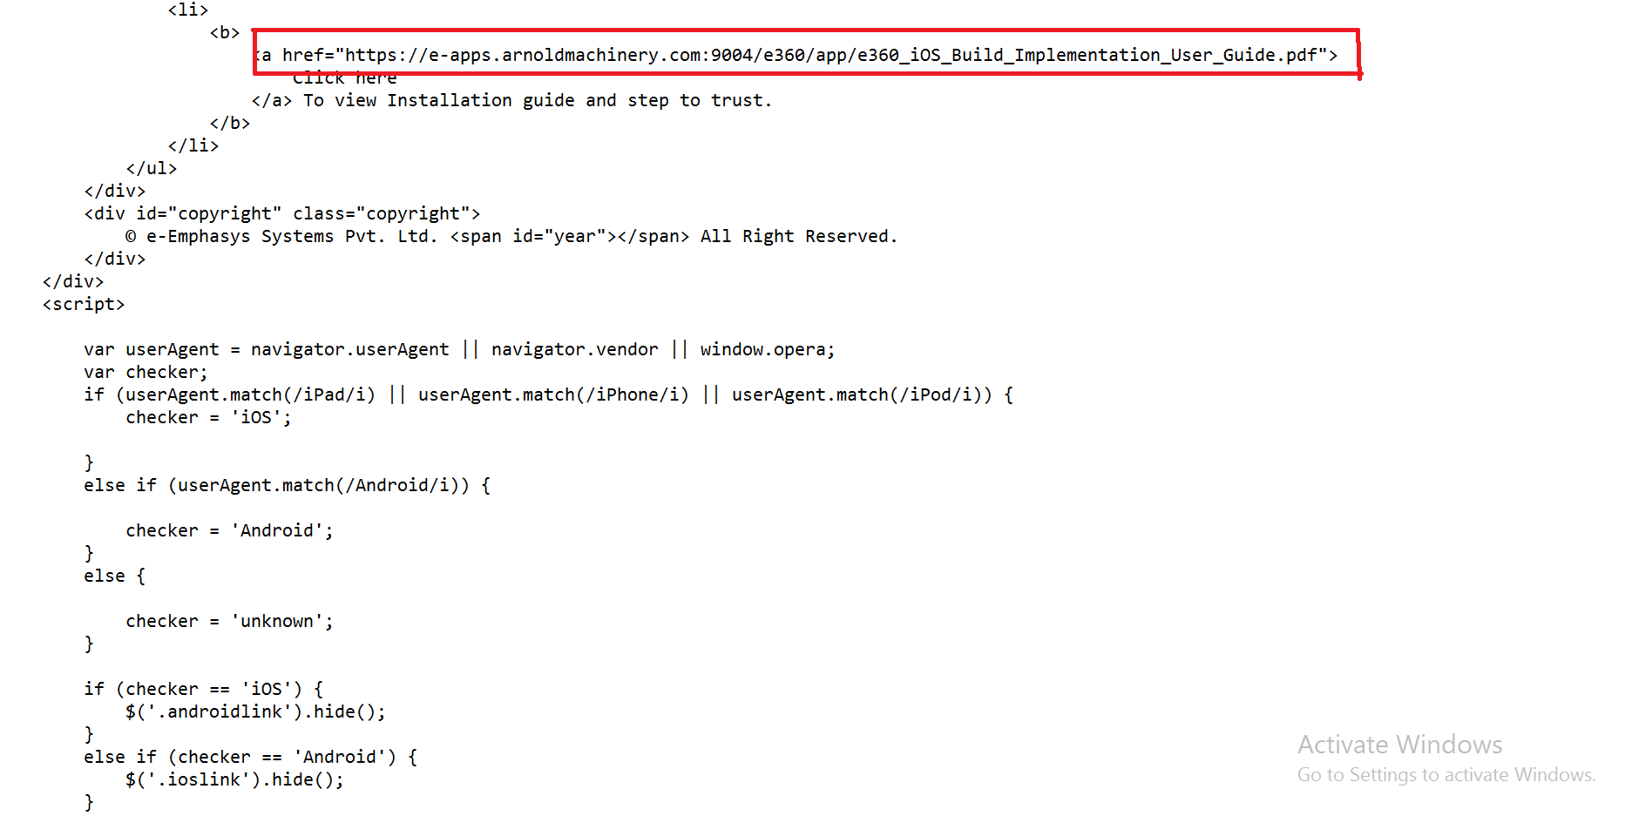
Figure 35: Update user guide link

- Open e360.plist file inside installable folder in notepad and change version and URL as per customer as shown below-

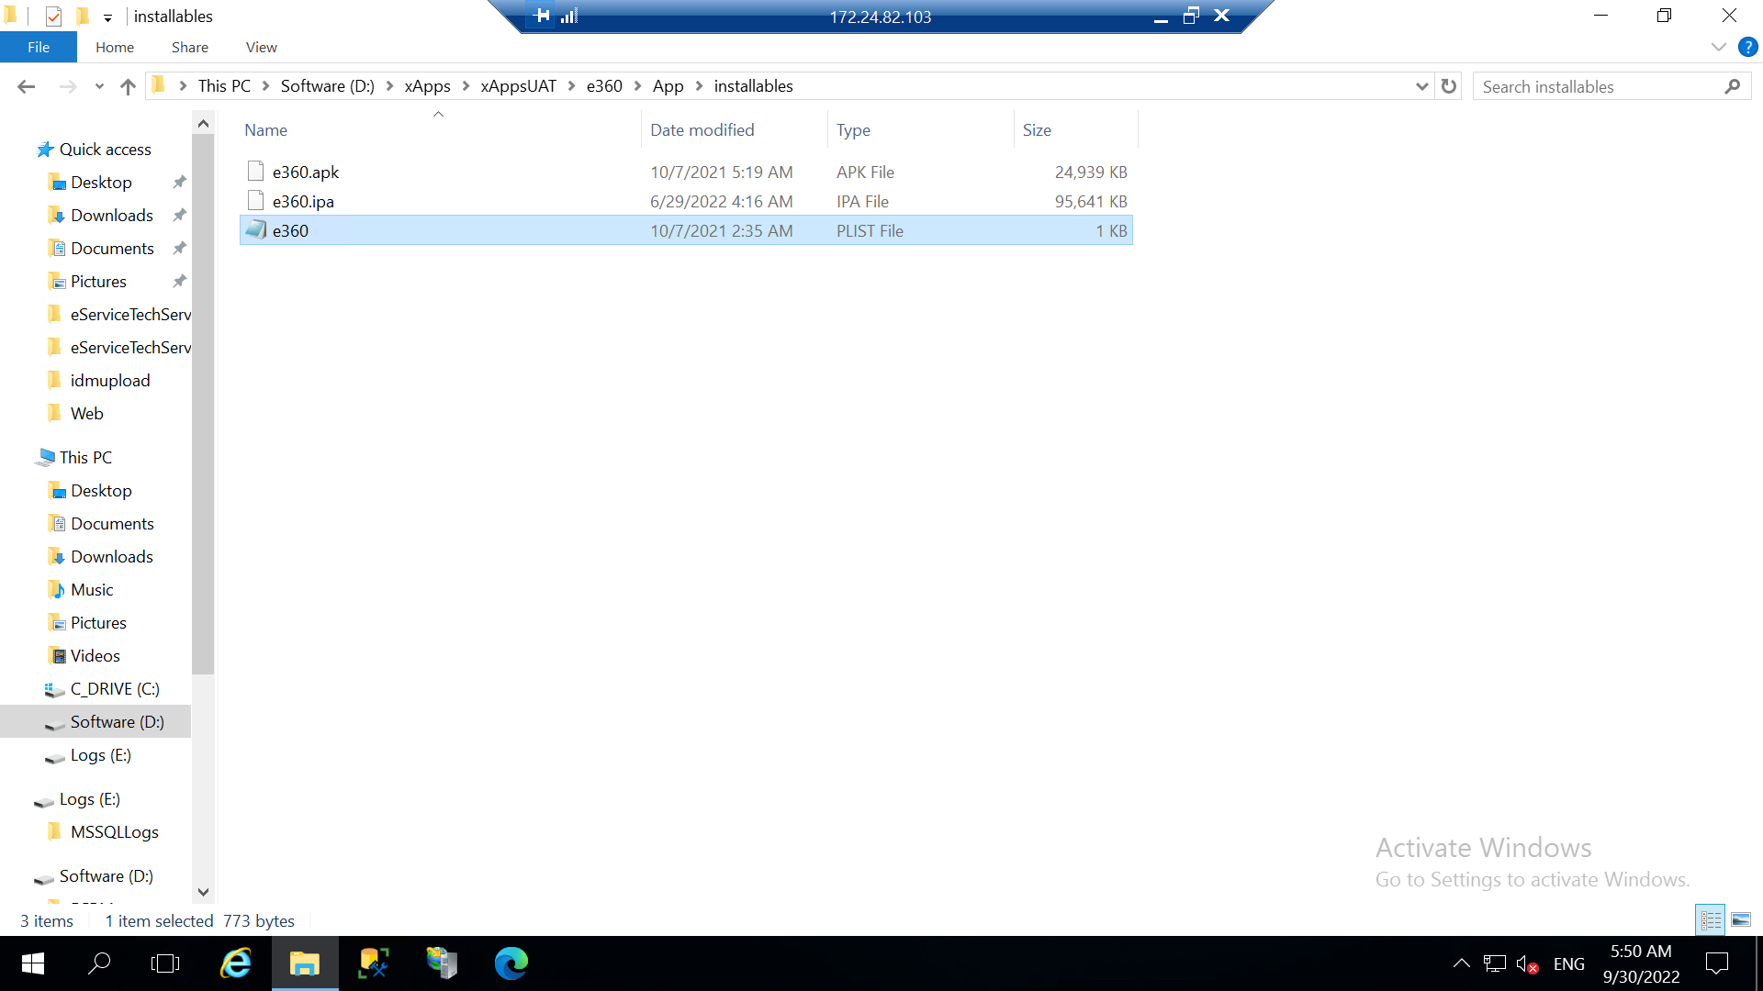
Figure 36: Folder view of plist file folder

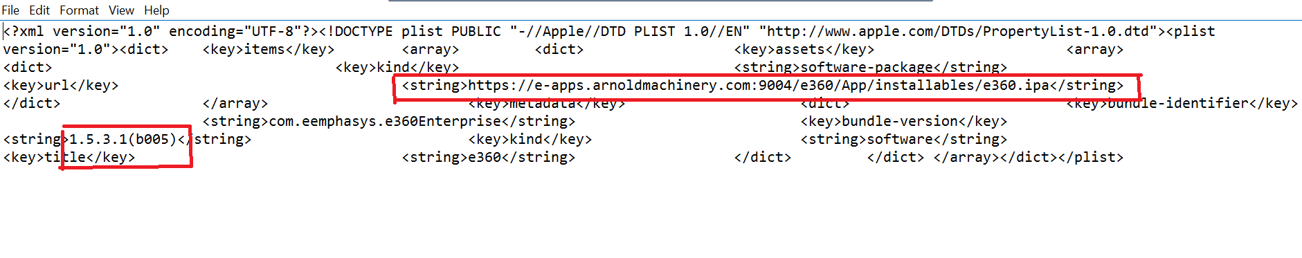
Figure 37: Update plist file with latest link and version

- For Fresh deployment and Upgrade-
1.Update builds-
Open Client Wise deployment package for respective client copy .apk and .ipa file as shown in below image and paste it inside ~\e360\installables folder.
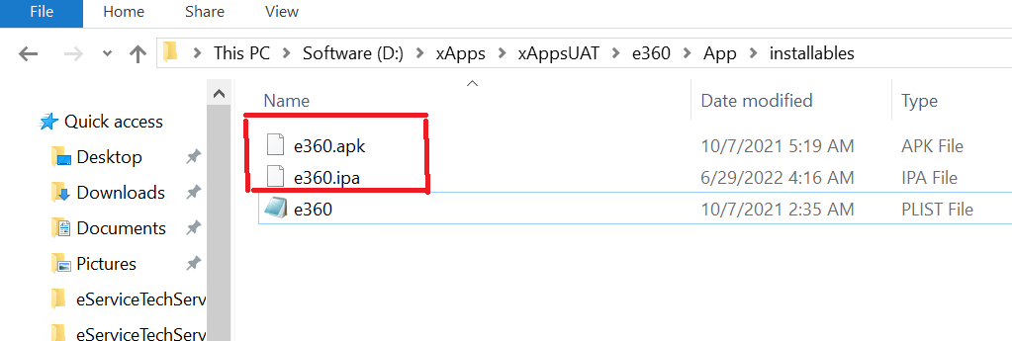
Figure 38: Update android and iOS build files

2.Update QR code image-
In client specific package you will get QR_Code.png file. Replace that file inside e360 => App =>images folder
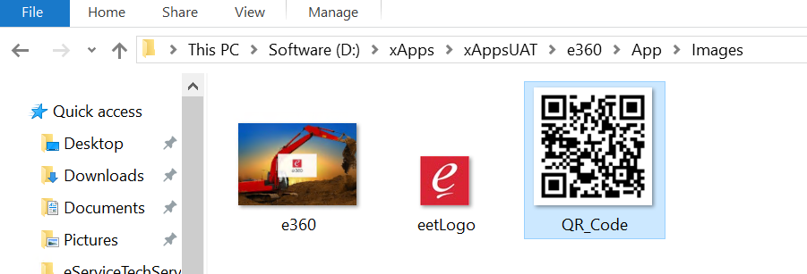
Figure 39: Update QR code image
3.Update version on index.html.
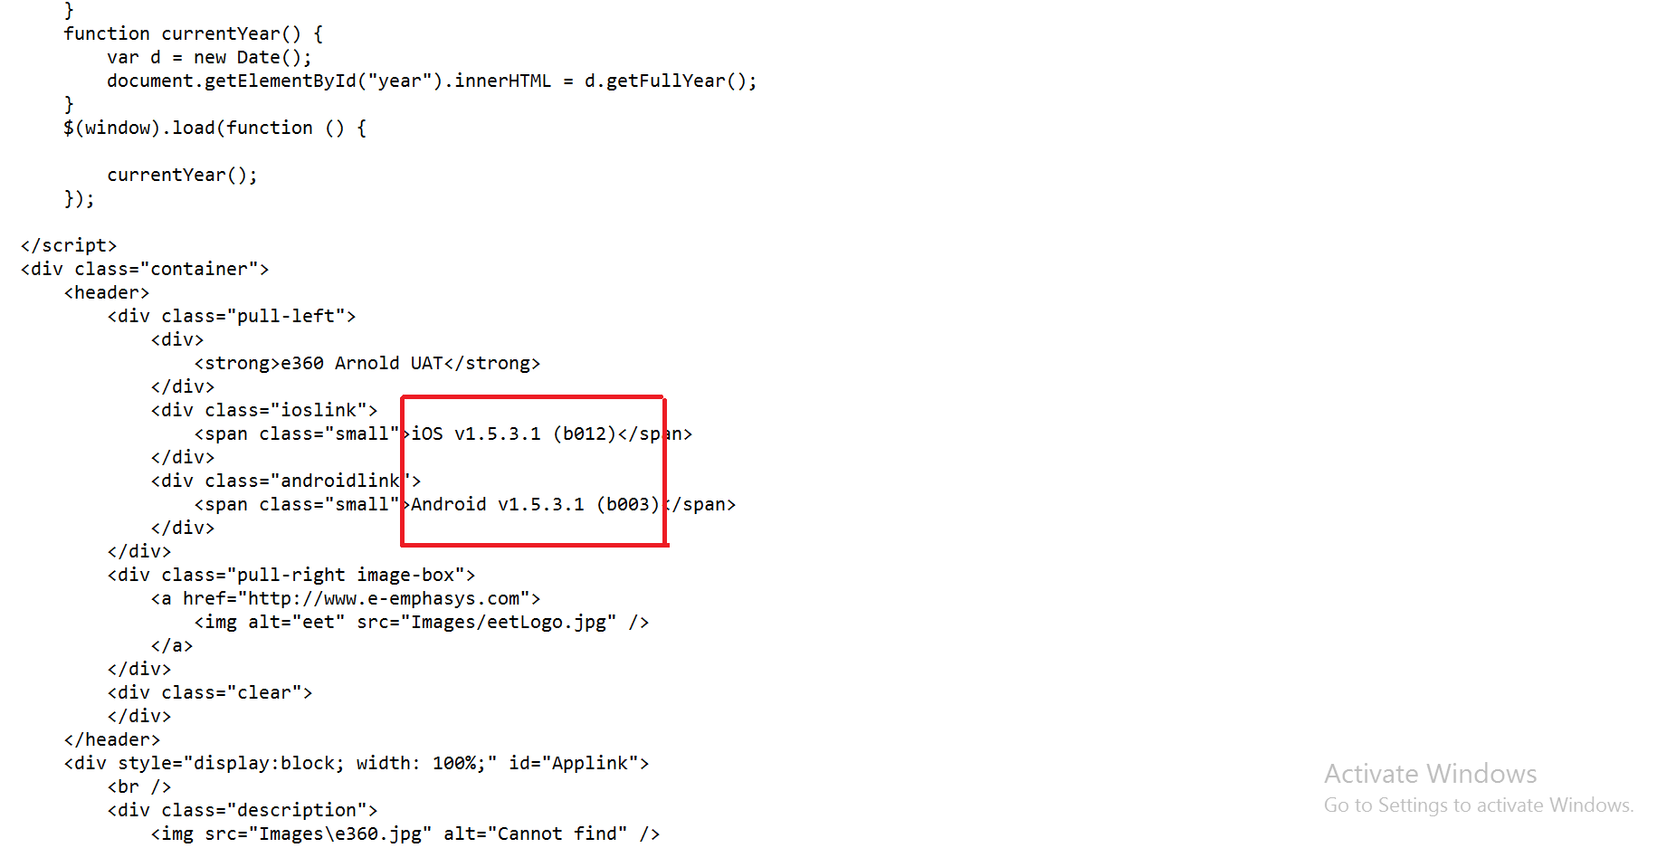
Figure 40: Update the version number and build number in index.html
4.Update version on e360QR.html.
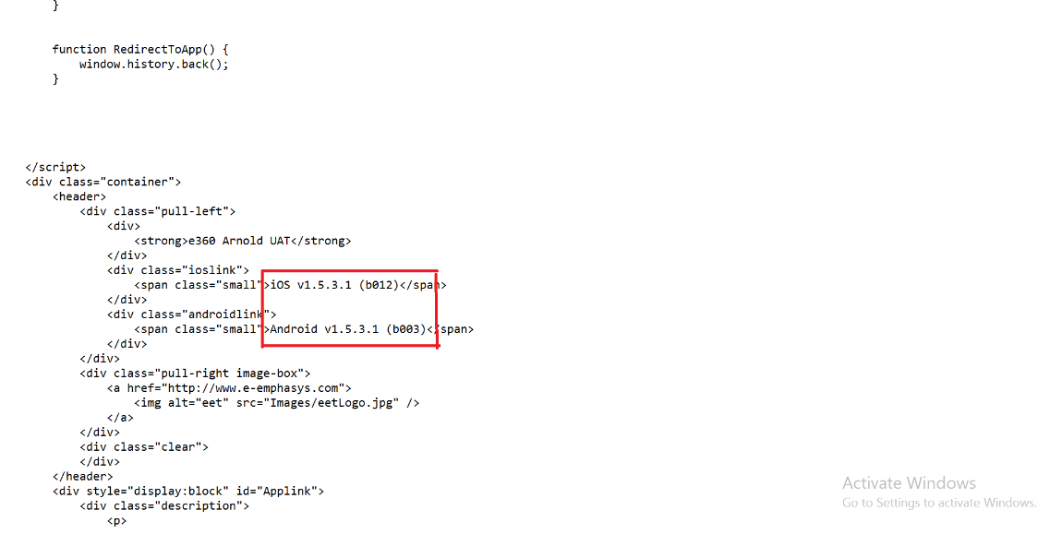
Figure 41: Update the version number and build number in e360QR.html

13. e360 Web application
e360 Web is a single page application developed on Angular JS 1.5. We need to configure the files below to host it on IIS.
- Index.html
  - This file needs to be modified only if it is hosted on a different virtual directory path as shown in section 5.2.
Below screenshot shows settings which require changes
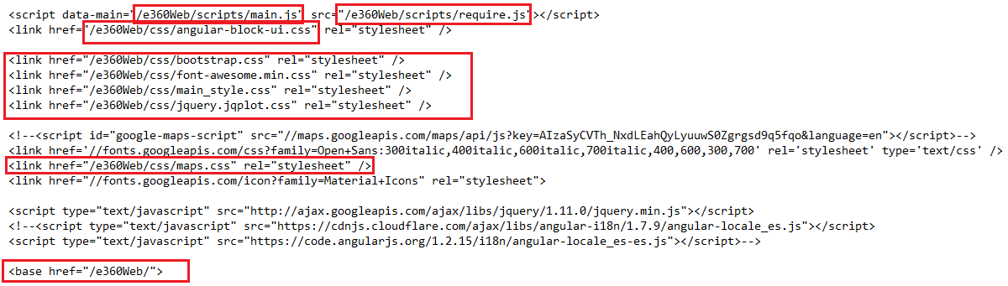
Figure 42: Update references path on Index.html

- Scripts/main.js
  - This file needs to be modified only if it is hosted on a different virtual directory path as shown in section 5.2.
Below screenshot shows settings which require changes
Note: highlighted setting should be changed in complete document.

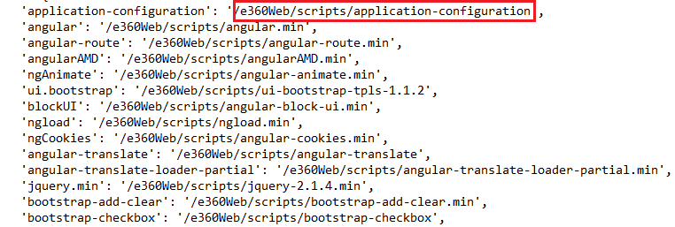
Figure 43: Update references path on main.js

- Services/CommonFunctionService.js
  - We need to edit this file to change the google map API key.
Note: you can find this key at the bottom of the document
Figure 44: Update google map API on CommonFunctionService.js
- Services/ConfigurationService.js
  - This file holds the service URL and application number (for display purpose)
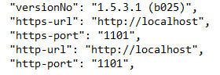
Figure 45: Update service path on ConfigurationService.js

CRM Team URI example:
https://e-apps.micore.us:9004/e360/e360Web/index.html?CustomerId=CustID&eXtendCompany=CID

14. Performing Smoke Testing for e360 Web
Smoke Testing is a testing process that determines whether the deployed software build is stable or not. This chapter explains the process of performing Smoke Testing for the e360 Web after the deployment is complete to verify whether the important features are working.
The steps for performing the Smoke Testing for e360 Web are explained below.
  - Test the services URL. If service link is https://e-apps.arnoldmachinery.com:9004/e360/Service/, then navigate to above link.
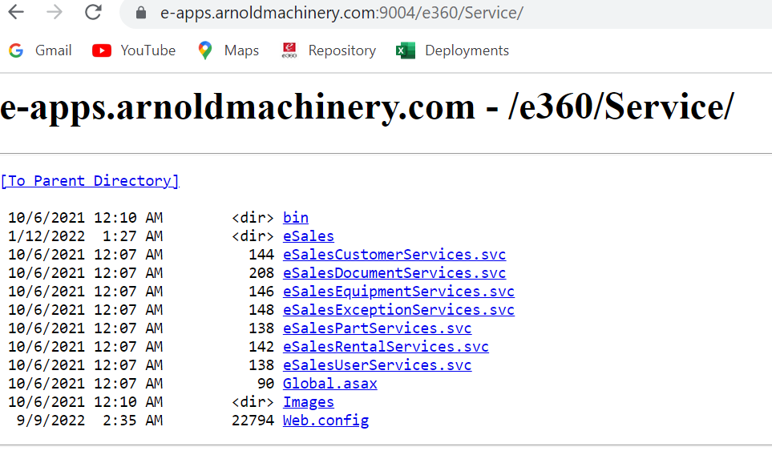
Figure 46: Check service URL
- Click on one of the services.
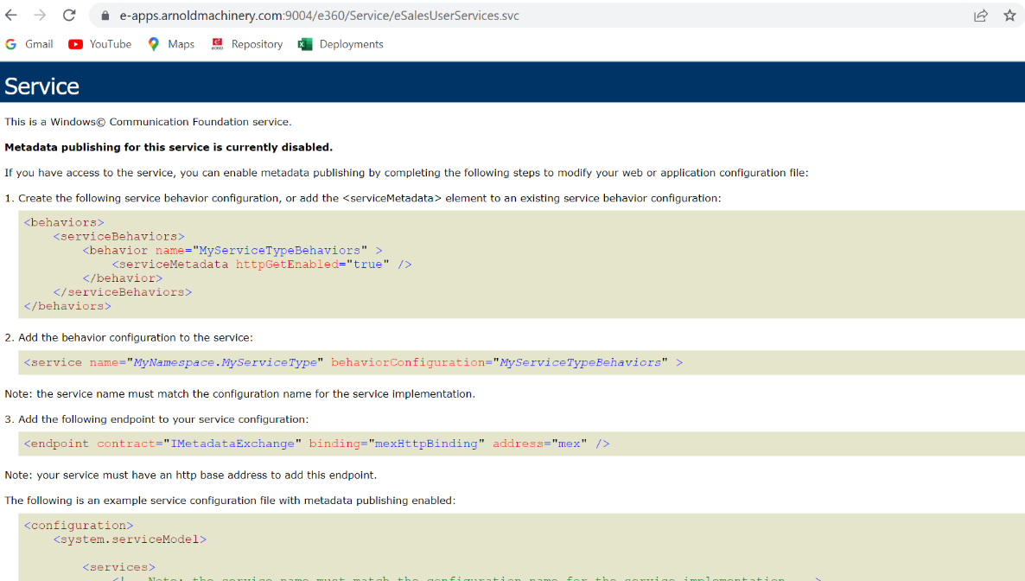
Figure 47: Click on any service and check the service endpoint

- Test the admin website if link is https://e-apps.arnoldmachinery.com:9004/e360/Admin/default.aspx, navigate on same.
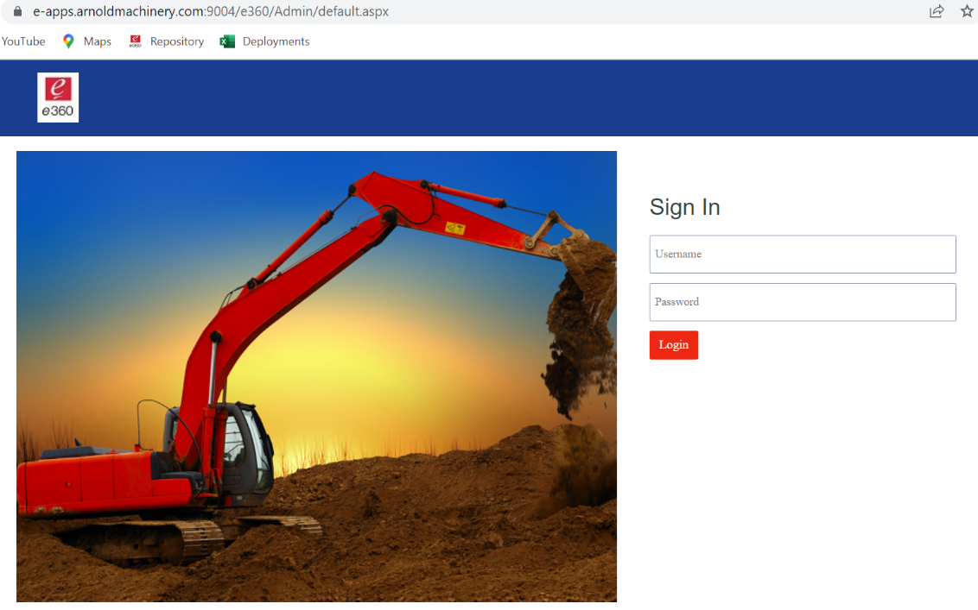
Figure 48: Check e360 admin URL
- On successful login to admin website User Management page is displayed.
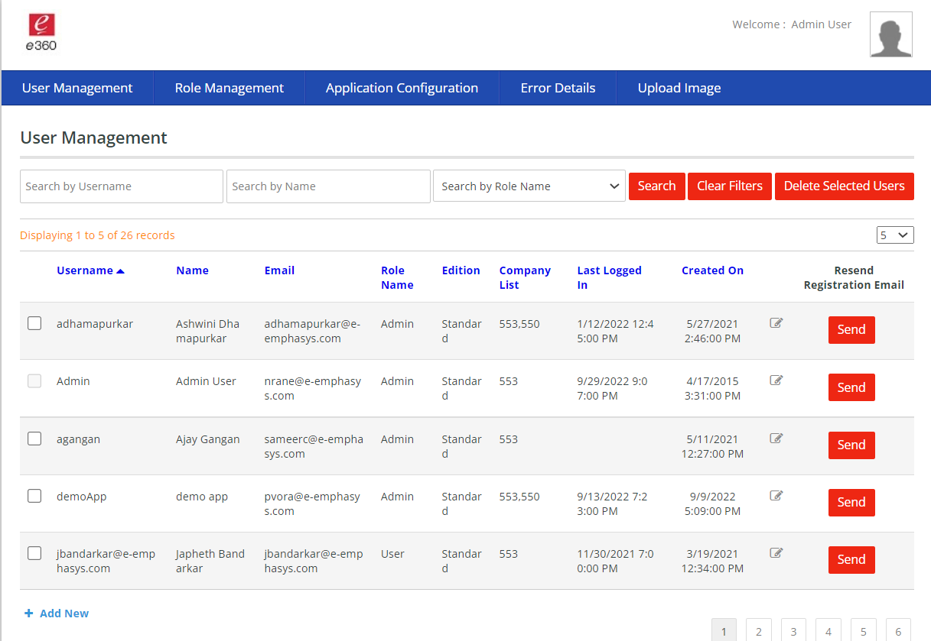
Figure 49: Login using admin / admin1234 credentials
- Create new user for testing, click on add new button
- On add new page, fill in the required details and click on save.
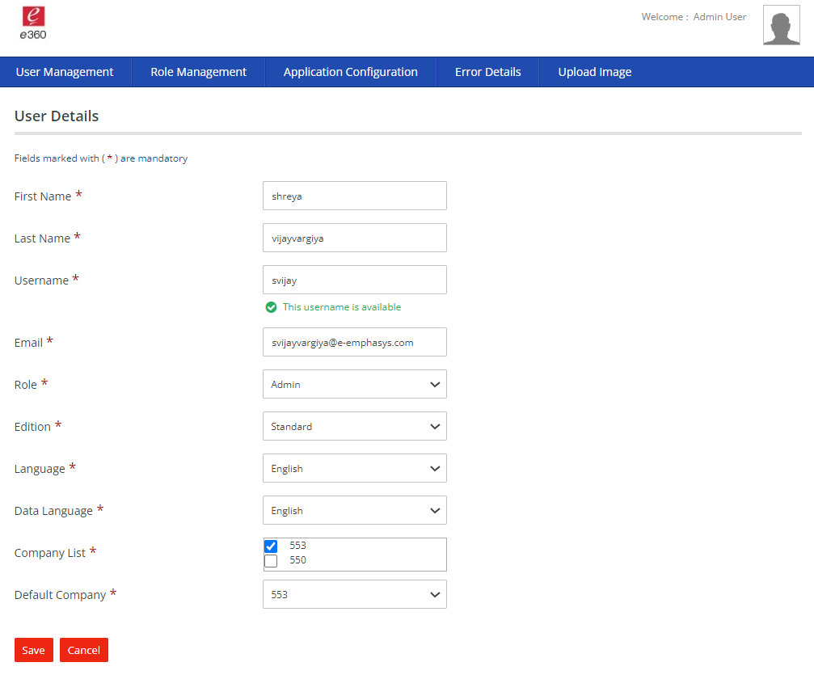
Figure 50: Add new users
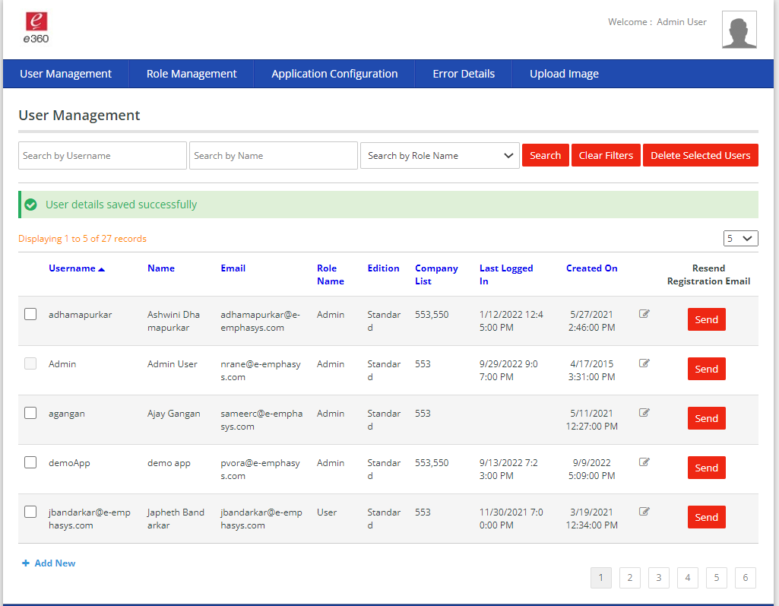
Figure 51: Save user success message
- User registration mail should be received on this step.
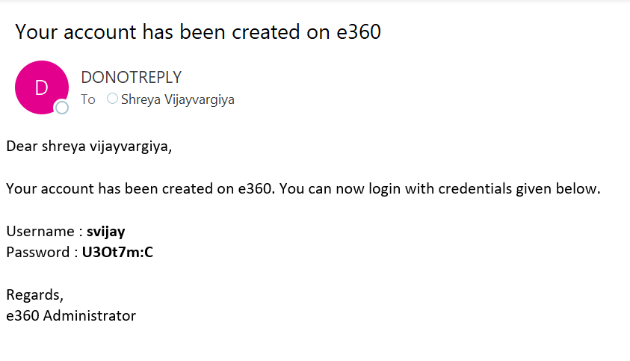
Figure 52: New user email
- Navigate on Role Management tab
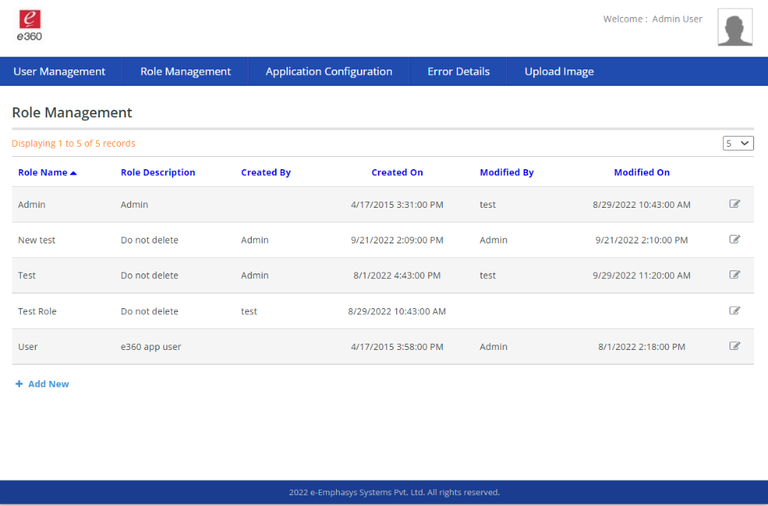
Figure 53: Role management list view

- Click on Application Configuration
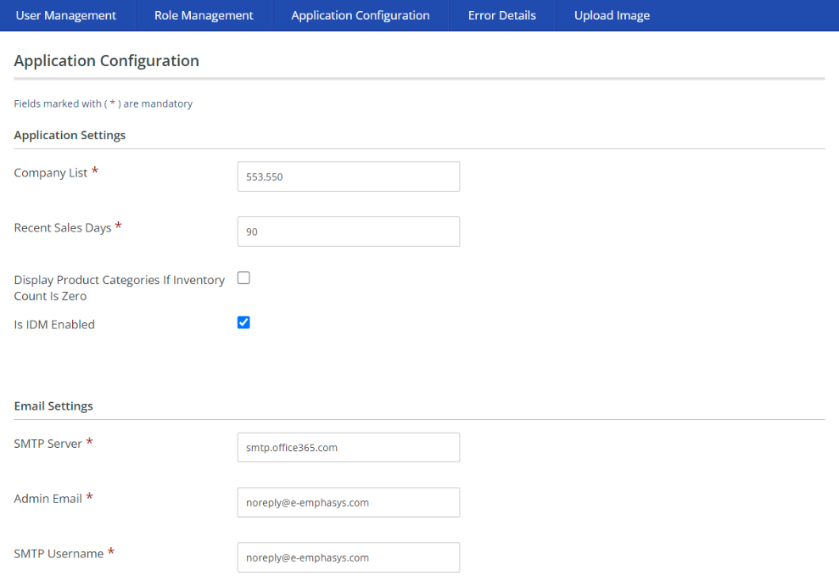
Figure 54: Application Configuration page
- Click on upload image tab
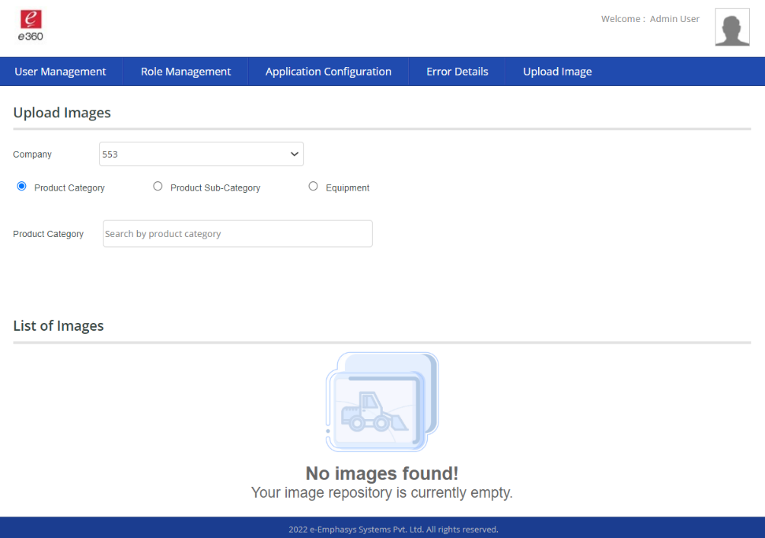
Figure 55: Upload image new look
- Test e360 web. Navigate to login page.
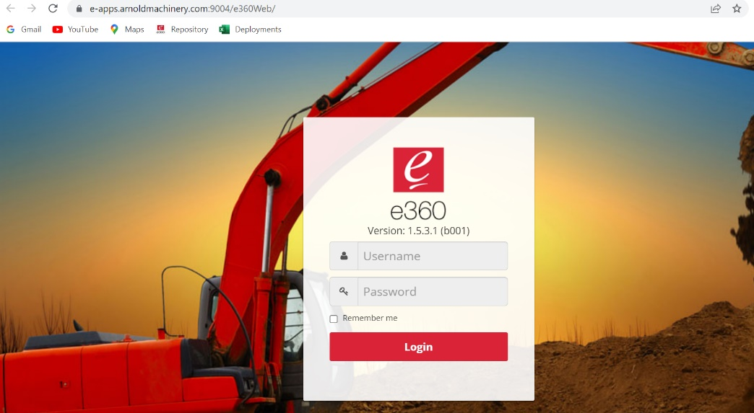
Figure 56: Check e360 web
- Login using username “admin” and password “admin1234”.
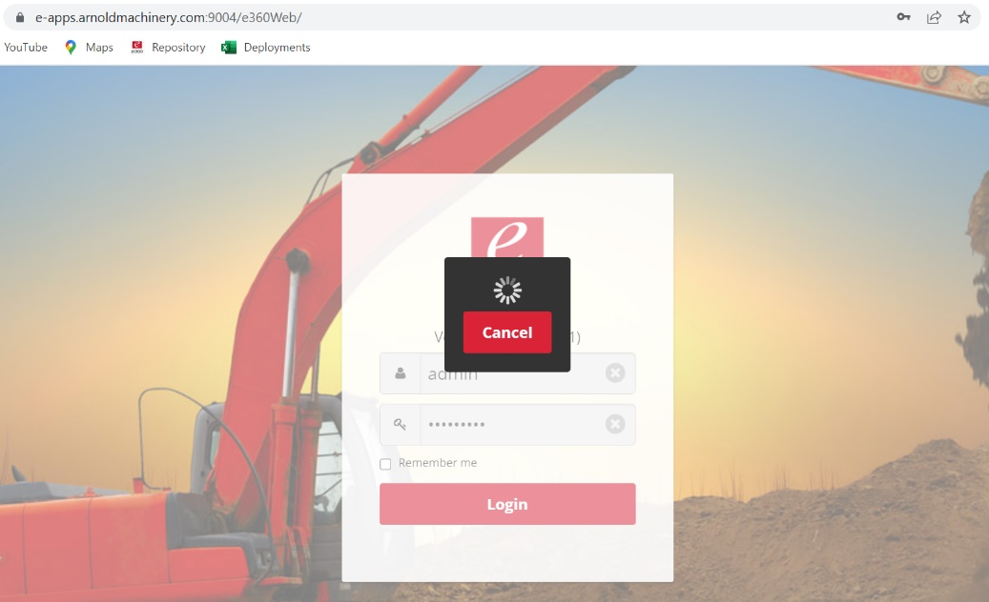
Figure 57: Login using admin credentials

- Home screen will appear, check different modules using this screen.
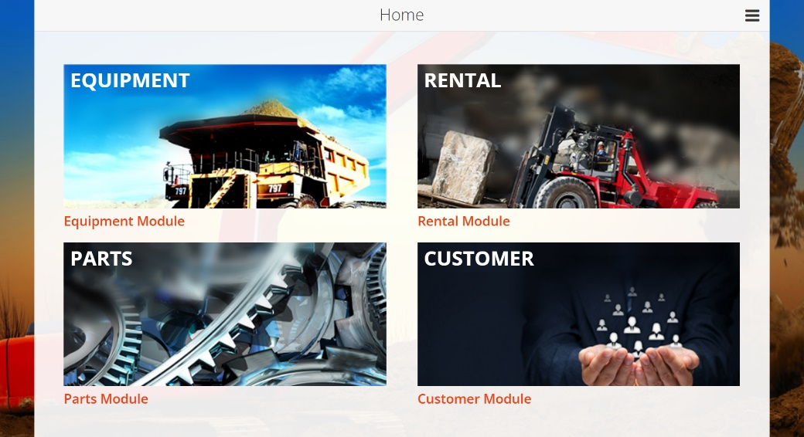
Figure 58: e360 Web home screen
- Click on equipment block, product category screen will appear with list of product categories
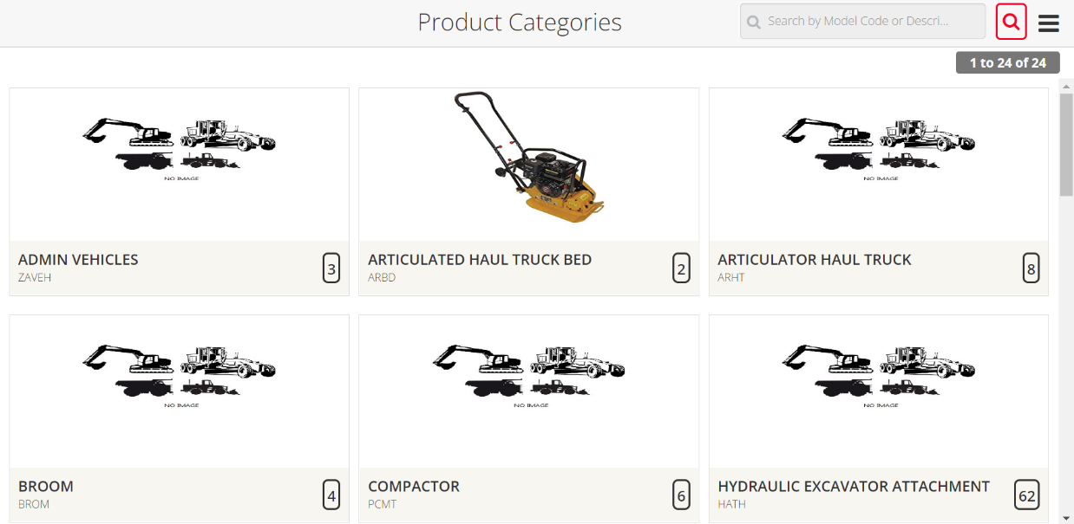
Figure 59: Click on equipment’s to view product categories
- Click on first product category in list, sub product category page will appear.
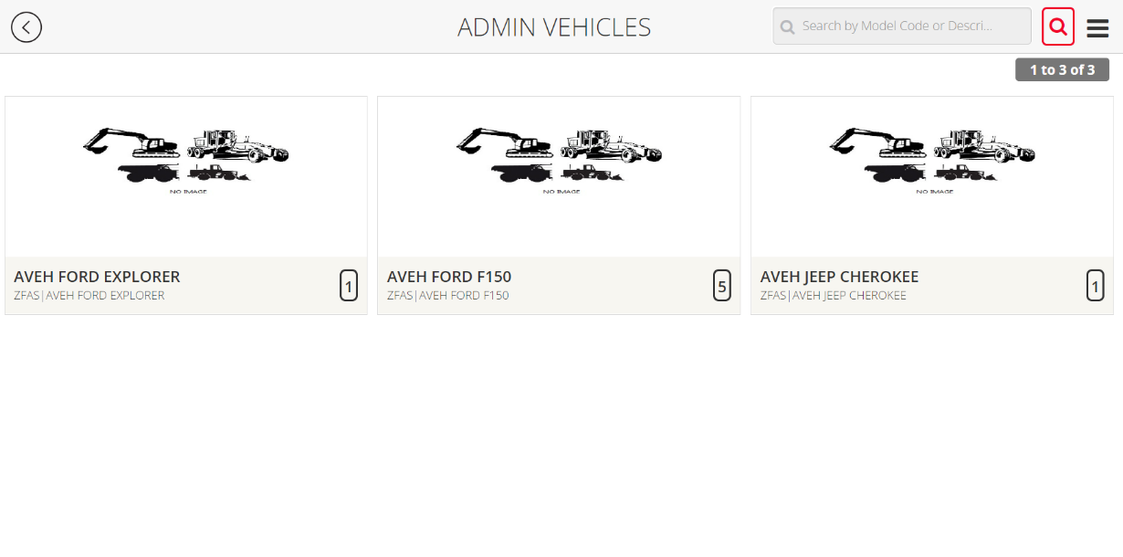
Figure 60: Sub product category view
- Click on first item in the sub product category list. Equipment details page will appear. Check details block, maps, and images.
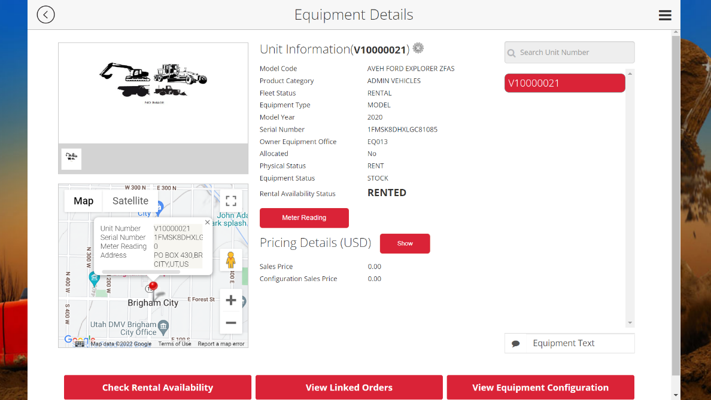
Figure 61: Check an equipment details page

- Click on Equipment Text/ Text button and check the page coming properly or not.
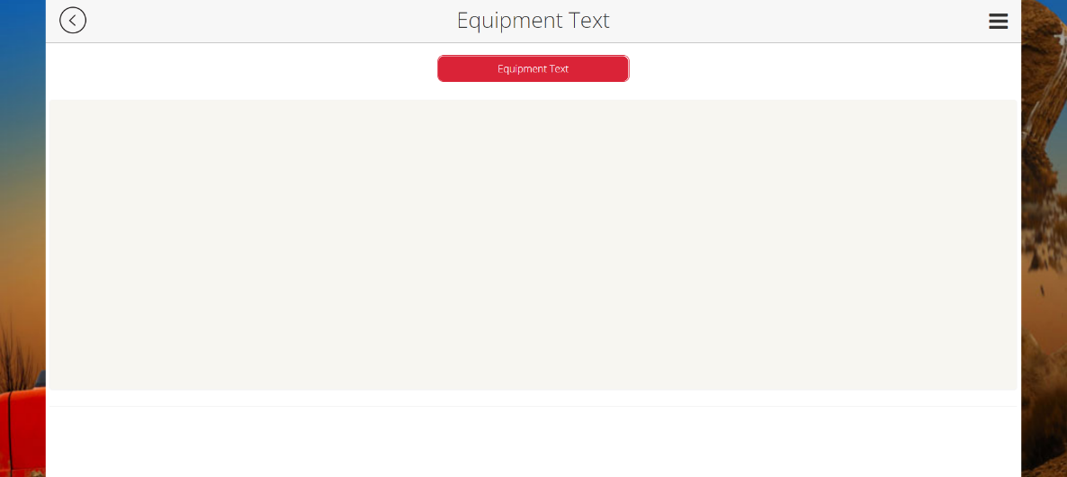
Figure 62: Click on text button to view texts
- Go back using back button on the top left corner of the application header and click on Check Rental Availability.
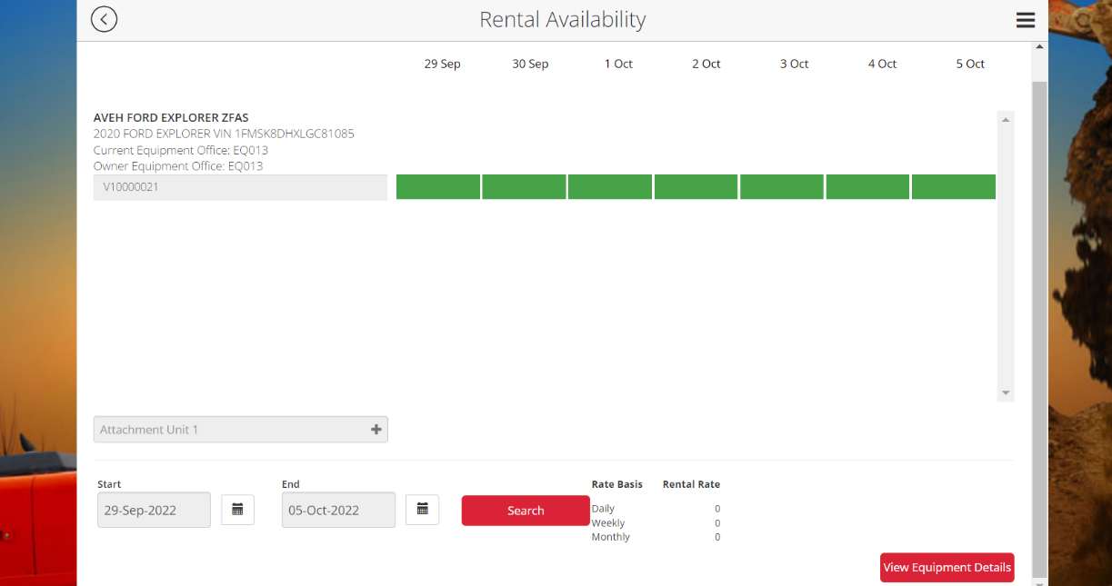
Figure 63: Check rental availability
- Click on the 3 lines on the top right corner and go to parts.

Figure 64: View parts
- Click on the search icon and go to advance filter page.
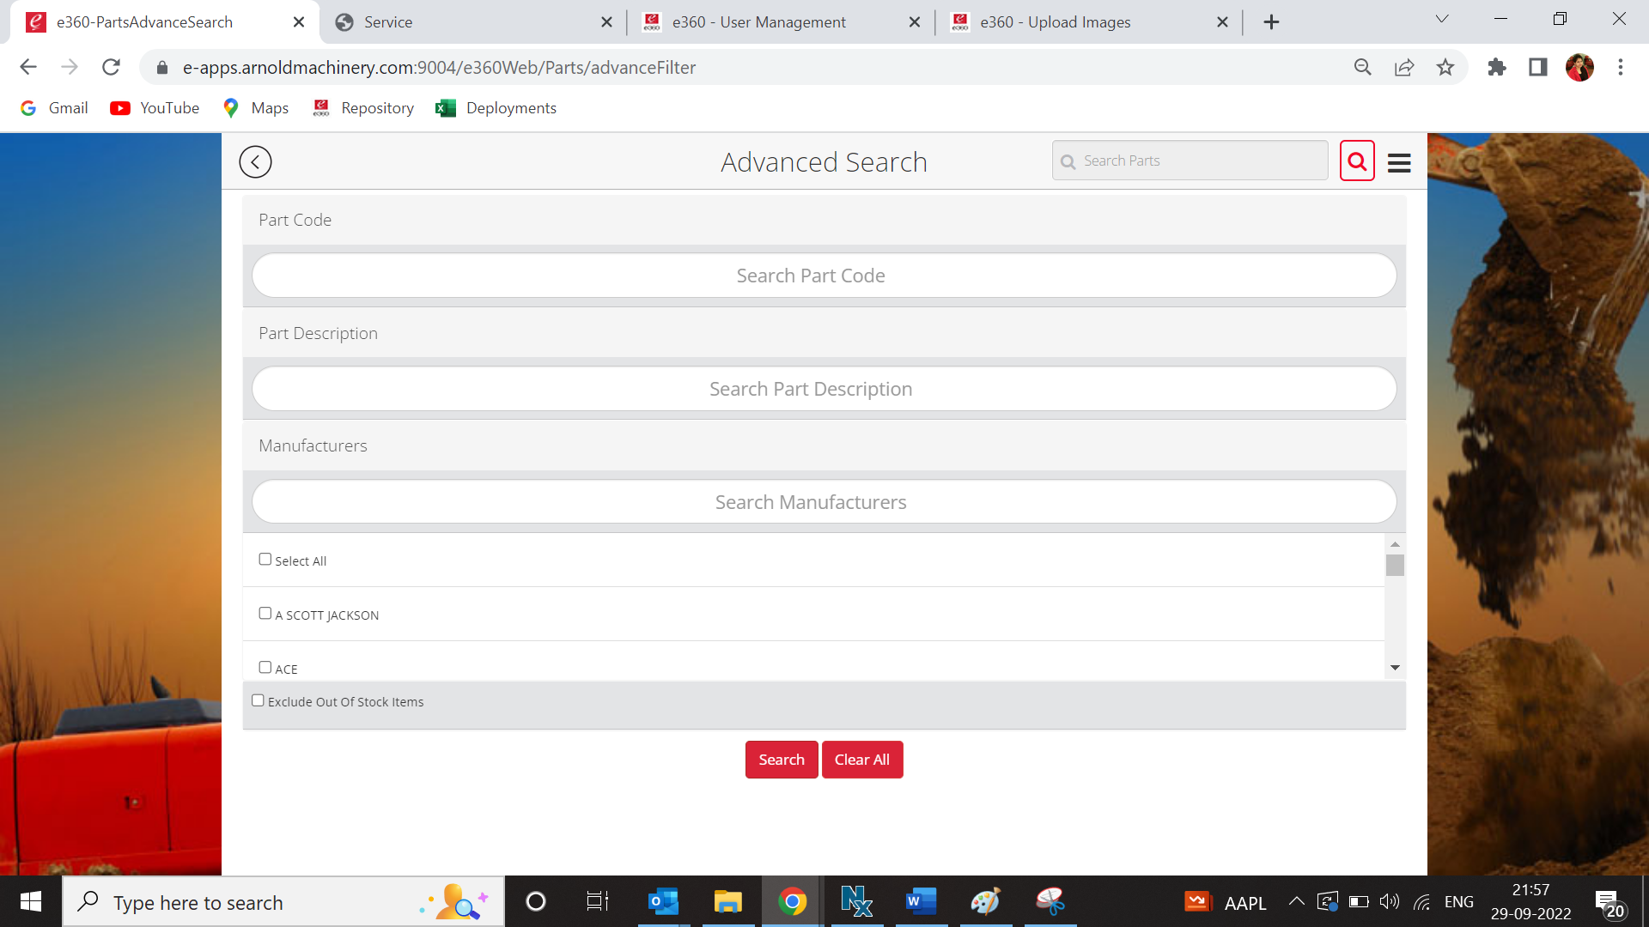
Figure 65: Parts advance search
- Click on search button and a new part list will appear.
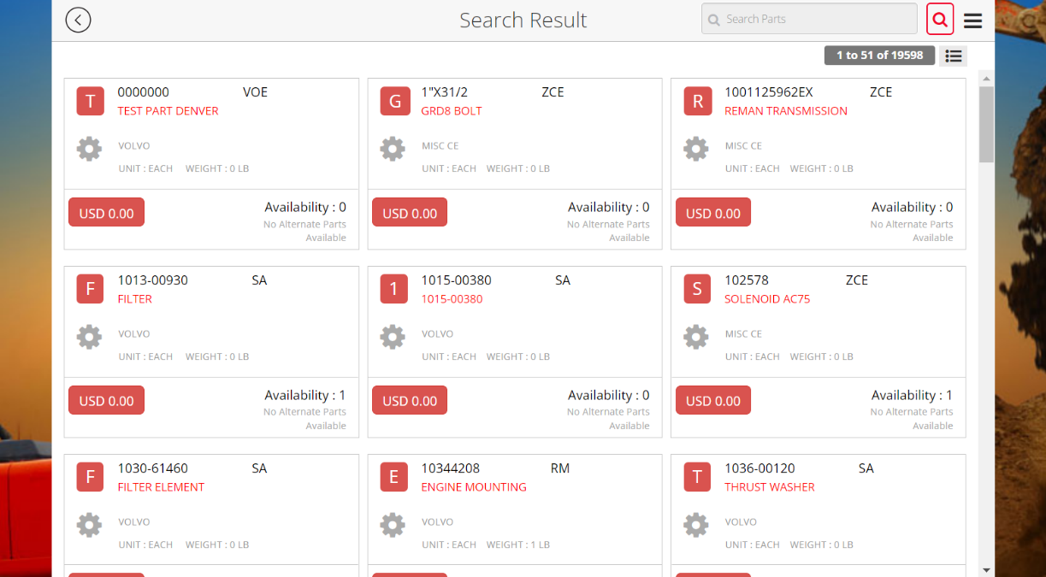
Figure 66: Parts list view
- Go to customer block using 3 lines on top right corner.
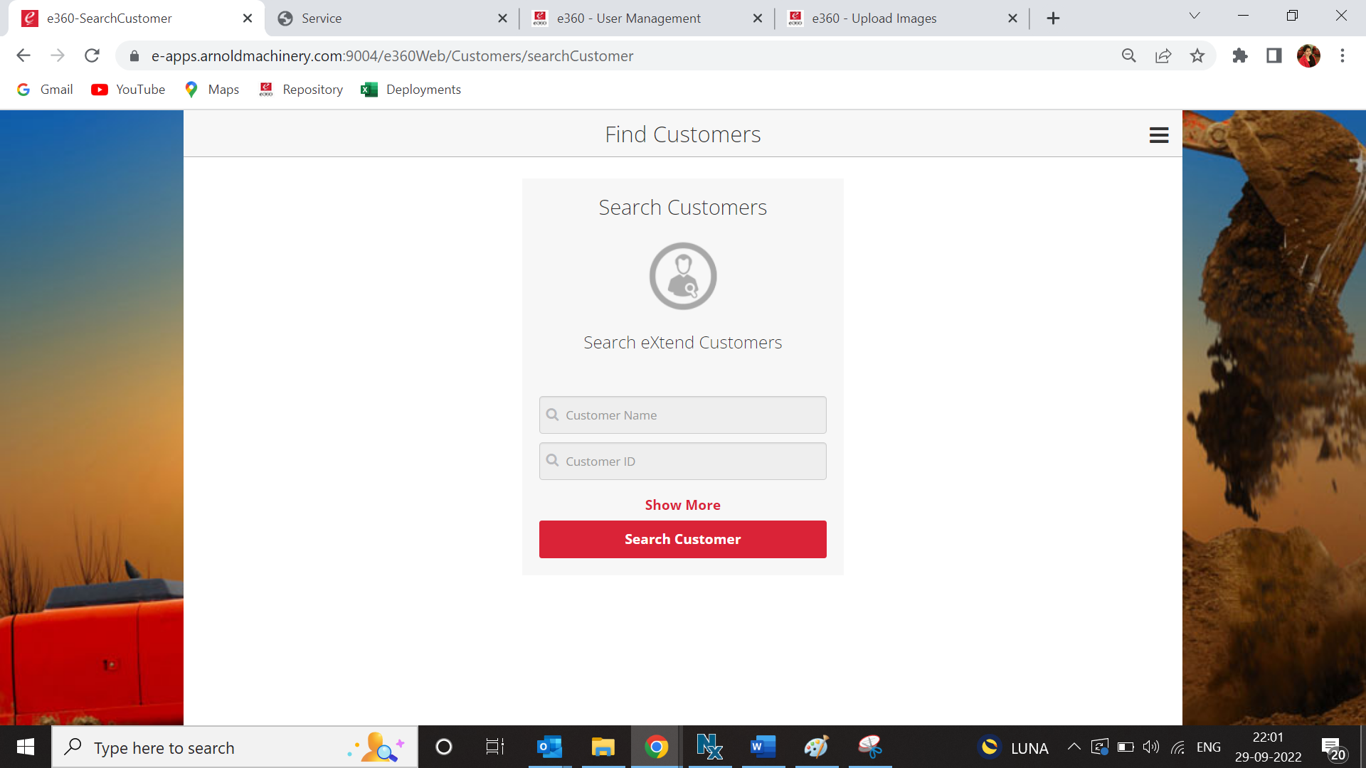
Figure 67: Customer search view
- Click on search button on Find Customer page and customer list will appear.
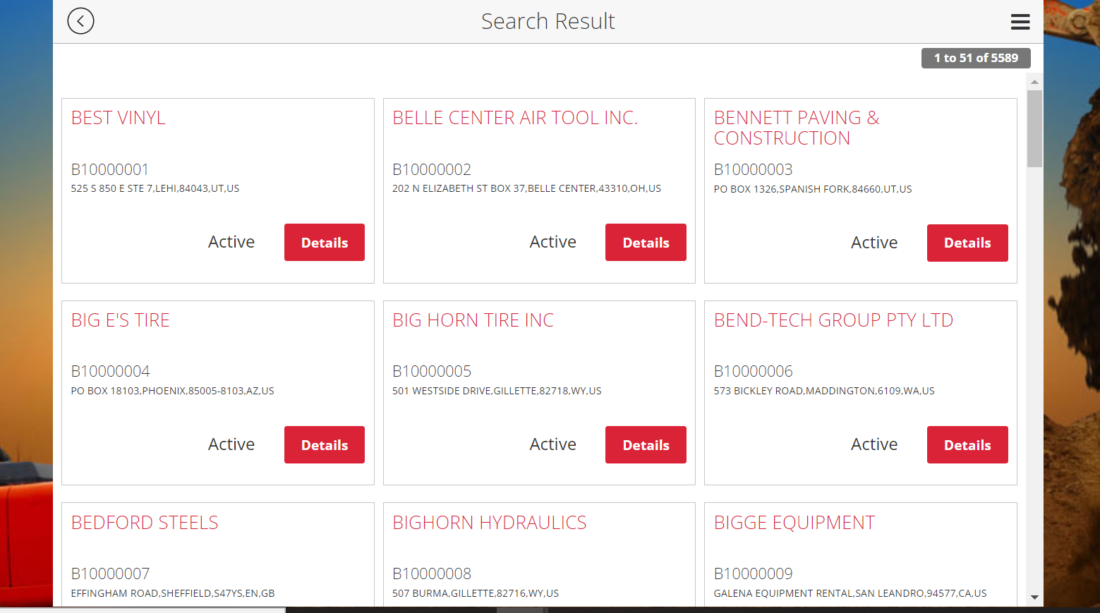
Figure 68: Customer list view
- Click on the first customer’s Details button in the list to check customer details page.
- On customer details page, check for maps, graphs and details on the contact info.
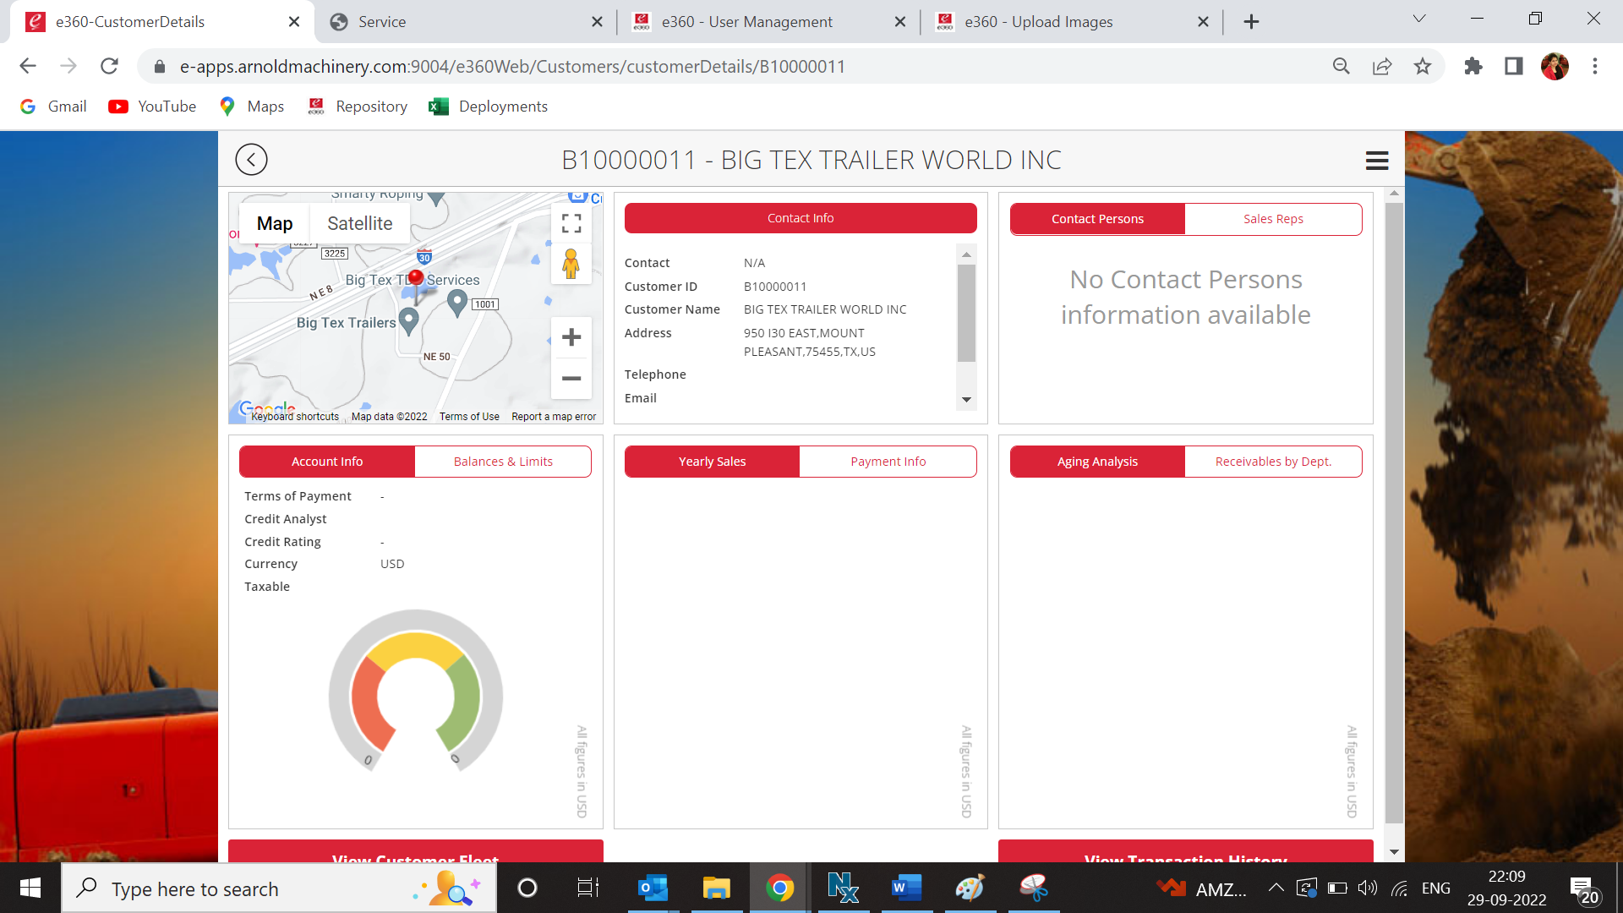
Figure 69: Customer details page

15. Maintaining QA Email Checklist
Once all verification is done, kindly fill the below checklist. Values will be different for different clients and environment. Below is an example of Arnold UAT.
TO- QA xapps.qa@e-emphasys.com; Ajay Gangan agangan@e-emphasys.com
CC- e360 e360@e-emphasys.com; Japheth Bandarkar jbandarkar@e-emphasys.com
Subject- e360 v 1.5.9.0 deployed on Arnold UAT
Body-
Hi Team,
We have deployed e360 version 1.5.9.0 on Arnold UAT environment.
Please verify e360 from your side and let us know if you see any issue.

Kindly refer following links for testing the application:
e360Web: https://eapps-fei.eetcld.com:8443/e360Web/
Admin: https://eapps-fei.eetcld.com:8443/e360/Admin/
App: https://eapps-fei.eetcld.com:8443/e360/App/

Kindly note below points-
Sr. No | Interface / Account Name | Applicable Yes / No | Operational Yes / No | Cause | Action Needed (None / Specify action) | Action By (EET AM / EET Product / EET IS / Customer)
1 | Google Maps | Yes | No | Customer did not provide Google API Key. | Customer needs to provide Google API Key, currently we have plugged in EET Google API Key on temporary basis. | Customer success Manager
2 | Emails | Yes | No | Customer did not provide SMTP details. | Customer needs to provide SMTP details, currently we have plugged in EET SMTP details on temporary basis. | Customer success Manager
3 | IDM | Yes | Yes | NA | NA | NA
4 | Apple Account (EET) | Yes | No | Customer did not provide Apple Account. | Customer needs to provide apple account details, currently we have plugged in EET apple account details on temporary basis. | Customer success Manager
5 | SMS | NA | NA | NA | NA | NA
6 | Video Call | NA | NA | NA | NA | NA
7 | Payment Gateway | NA | NA | NA | NA | NA

16. Update Link Repository
1.Open below link in browser-
https://xapps1.e-emphasys.com:10000/LinkRepository/Admin/Default.aspx

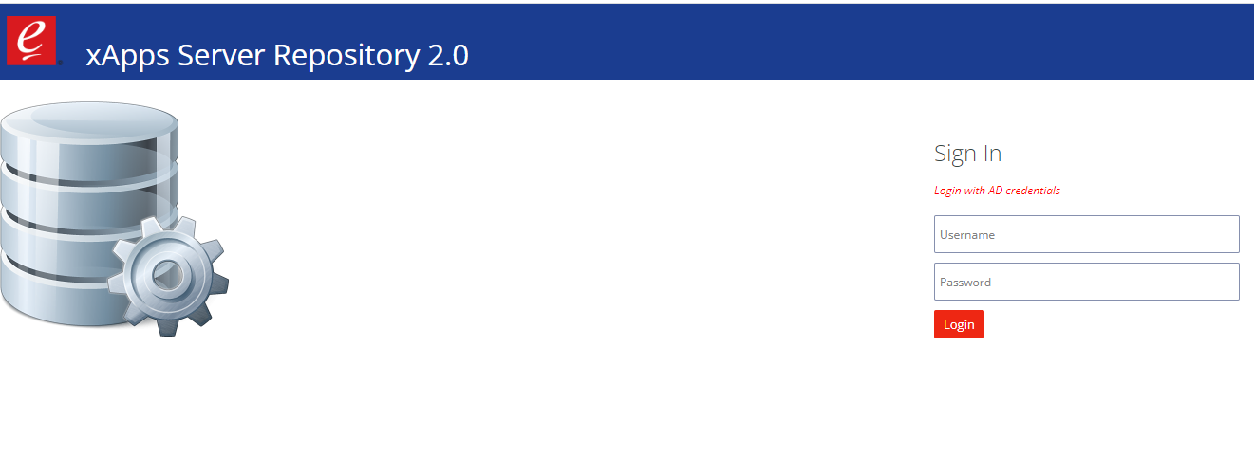
Figure 70: Link repository

2.Login with your credentials.
3. Click on xApps Link Repository tab-
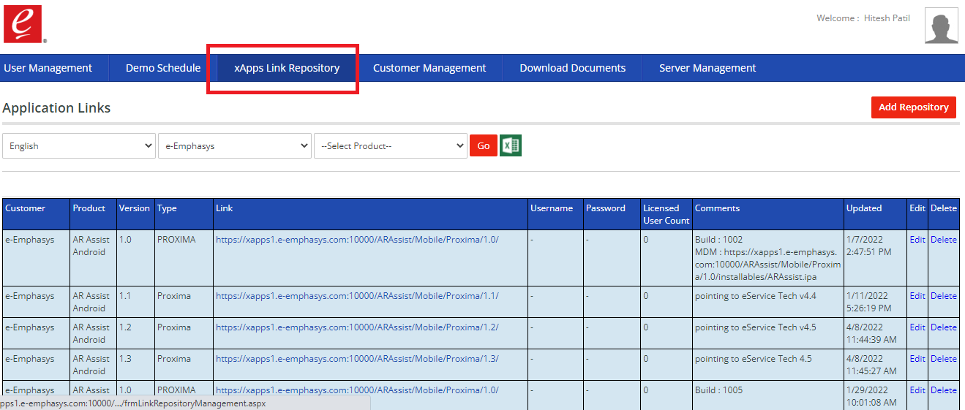
Figure 71: Go to xApps link repository

- Fresh Deployment-
- For fresh deployment click on Add Repository-
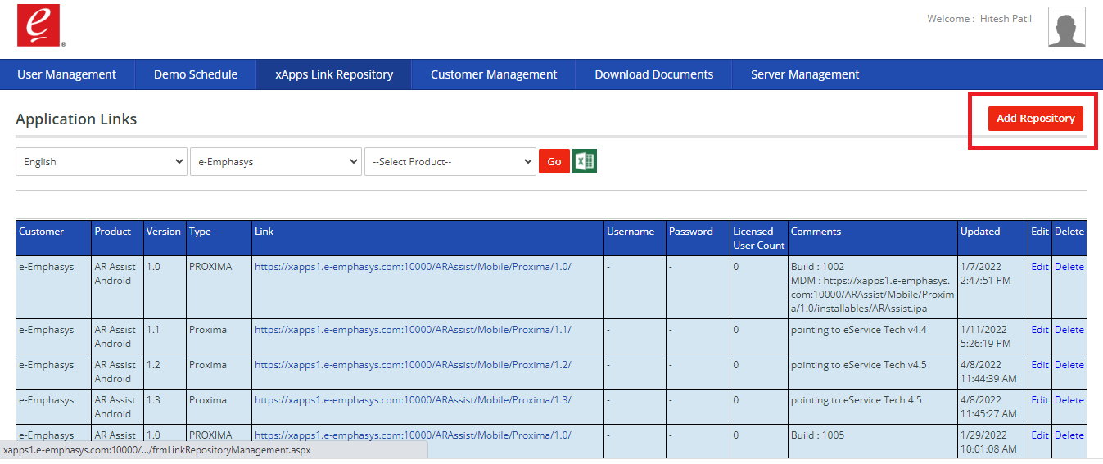
Figure 72: Search for required customer

- Add details as shown in below image and click on save button-
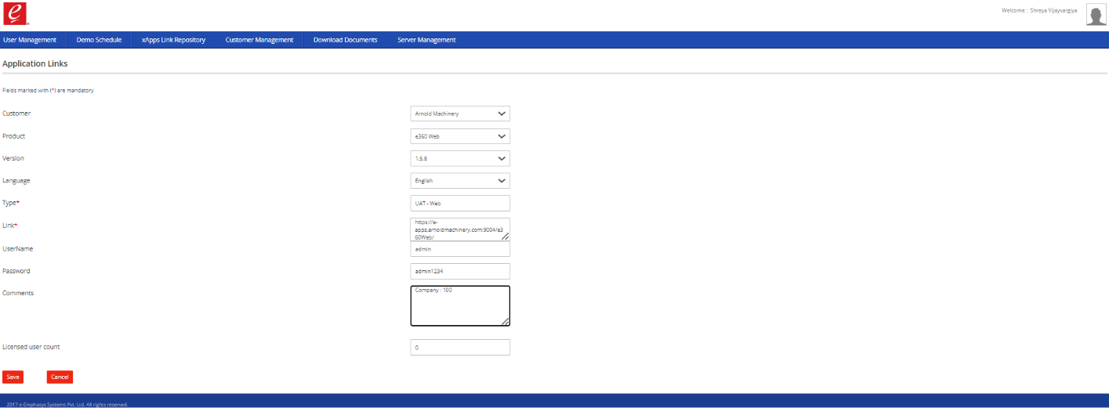
Figure 73: Add or update new customer specific data

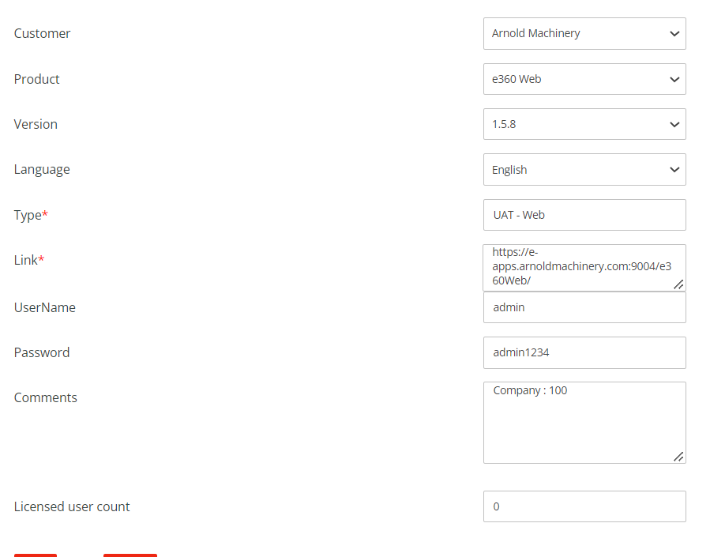
Figure 74: Fill up the required data

- Set Type- UAT Application or Live Application as per requirement above example is shown for Linder UAT.

- Upgrade –
i) After login and clicking on xApps Link Repository.
ii)Select required customer and e360 Web product and click on Edit button for record you want to edit.
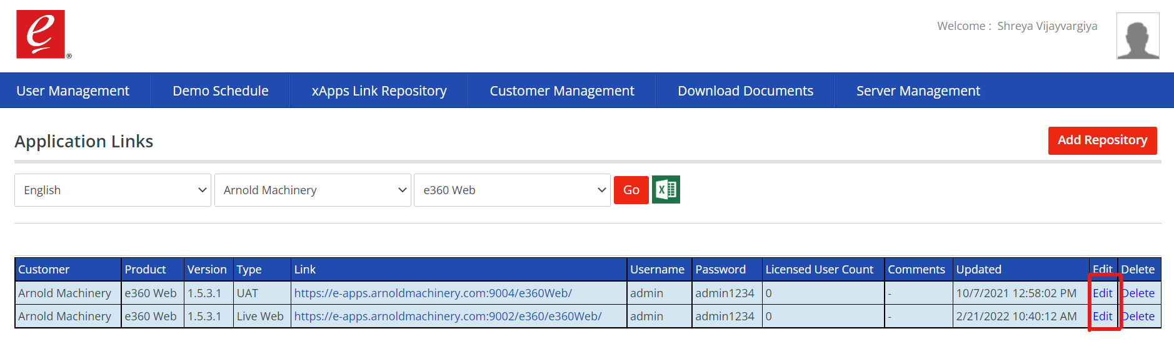
Figure 75: Edit the existing entry

iii)Update Version and other details if any and click on Save.

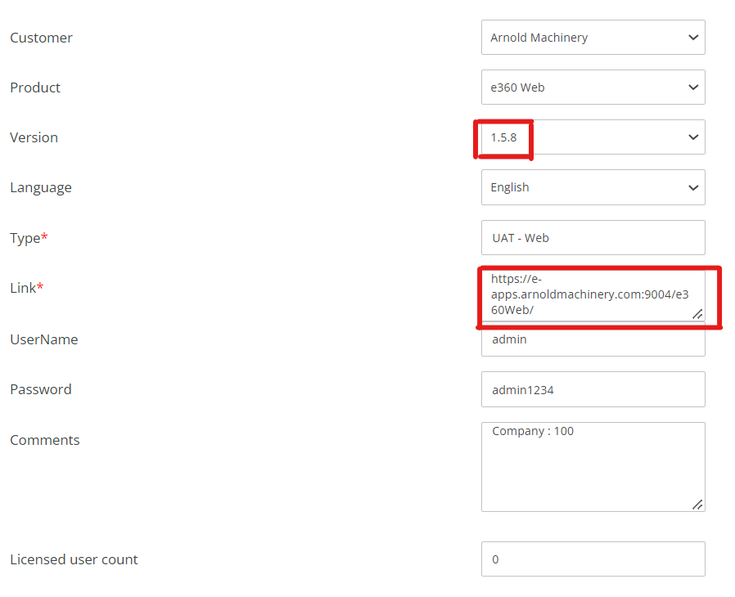
Figure 76: Update the details and save it

